Meusburger Georg GmbH & Co KG
Kesselstr. 42, 6960 Wolfurt, Austria

Exclusively at Meusburger: DLC coated flat guiding stock

The advantages of DLC coating are clear: longer service life and reduced maintenance. The new E 3174 flat guiding stock from Meusburger guarantees optimal sliding properties and minimal wear thanks to the DLC coated surface. With the radii already provided at the corners, the flat guiding stock can be fitted into milled pockets. As well as this, thanks to identical fitting dimensions, the new E 3174 can be used to replace the existing self-lubricating flat guiding stock E 3176 where necessary. In order to avoid sharp edges, a 15° chamfer is provided around the entire plate. This ensures a longer service life of the flat guiding stock, clean operation of the mould, and easy installation without rework. The plates are available immediately from stock, with dimensions from 25 x 63 mm up to 63 x 200 mm.

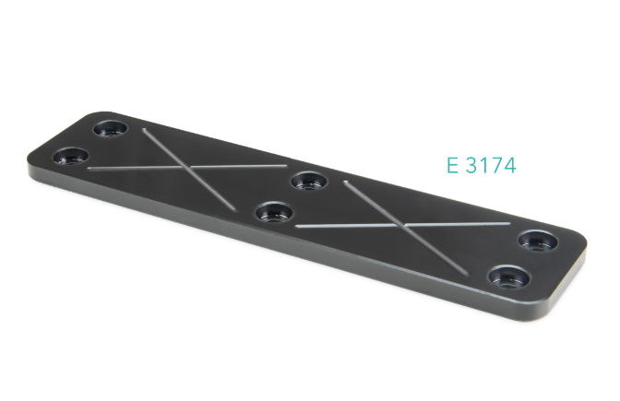

Picture credits: Photo (Meusburger)
Caption: Only available at Meusburger: DLC coated flat guiding stock

Meusburger – Setting Standards.

As a part of the Meusburger Group, the Meusburger company is the market leader in the field of high-precision standard parts. Customers all over the world make use of the advantages of standardisation and benefit from the company's over 50 years of experience in working with steel. Offering an extensive range of standard parts, combined with selected products in the field of workshop equipment, Meusburger is the reliable global partner for making moulds, dies, jigs and fixtures.

Further information:
Meusburger Georg GmbH & Co KG
Communication / Public relations
Phone: + 43 5574 6706-0
Email: press@meusburger.compresse@meusburger.com
http://www.meusburger.com/en/press/press.html

