Meusburger Georg GmbH & Co KG
Kesselstr. 42, 6960 Wolfurt, Austria

NEW from Meusburger – Ejectors for longer service life

The new HSS ejector pins and DLC coated blade ejector pins with extra long blade from Meusburger guarantee long life and minimal wear. The use of high-speed steel and diamond-like carbon coating results in longer maintenance intervals and reduced downtimes. The two high-quality ejectors are as usual with Meusburger, available from stock.

HSS ejector pins
When using HSS ejector pins, moulds can be operated at higher temperatures due to the pins' excellent high-temperature resistance. In addition, minimal wear is guaranteed through their hardness of ~64HRC.

DLC coated blade ejector pins with extra long blade
The DLC coated blade ejectors assure highest precision and longest service life through the best sliding properties. Excellent corrosion resistance is in addition to their usability in cleanrooms a further advantage of the DLC coated ejectors. Available with 2 or 4 angle radii, the blade ejectors are ideally suited for the installation in EDMed apertures.

Picture credits: Photo (Meusburger)
Caption: New ejectors from Meusburger ensure longer service life

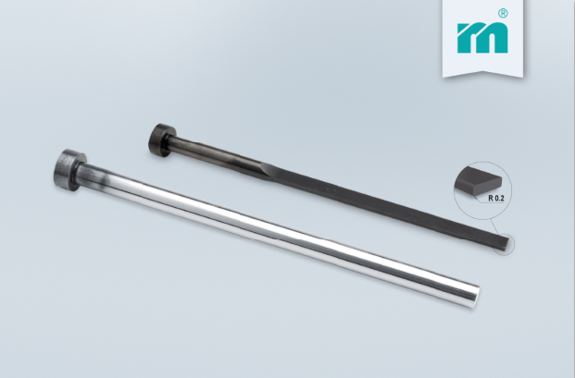

Meusburger – Setting Standards
Meusburger is the leading manufacturer of high-precision standard parts. More than 17,000 customers all over the world make use of the numerous advantages of standardisation and benefit from the company's over 50 years of experience in working with steel. Offering an extensive range of standard parts, combined with high-grade products in the field of workshop equipment, Meusburger is the reliable global partner for making dies, moulds, jigs and fixtures.

Further information:
Meusburger Georg GmbH & Co KG
Communication / Public relations
Phone: 0043 (0) 5574 6706-0
Email address: presse@meusburger.com
http://www.meusburger.com/press-releases

