Meusburger Georg GmbH & Co KG
Kesselstr. 42, 6960 Wolfurt, Austria

Merger of Meusburger and PSG China

A new chapter of the cooperation of Meusburger and PSG in China began on September 1, 2017. As of the effective date Meusburger Mould and Die (Wuxi) Co. Ltd is legally an entity.

Picturesquely located on Lake Taihu and on the shore of the Yangtze river, the six million inhabitant metropolis Wuxi is often also called little Shanghai. Wuxi has also expanded greatly economically: the city in the province Jiangsu is one of the eastern Chinese economic centres and is regularly included in the Top 10 best Chinese business cities.

This is why Meusburger already opened a sales branch in Wuxi in 2010. PSG has a representation in the Middle Kingdom since 2015. Many customers have their location in the Wuxi region and also more than half of the turnover in China is earned here. Meusburger and PSG jointly obtained new office spaces in summer and are now on site with more than 40 employees.

Together with the new office spaces – a warehouse of 250m² was set up – in accordance to Meusburger’s guiding principle of permanent availability. Already a big part of all parcels come directly from the new warehouse and can be dispatched all over China within two working days.

Enormous synergies can be used through the merger of Meusburger and PSG: the majority of the customers are relevant for both Meusburger and PSG. They benefit from an expanded portfolio, central service performance and the shared know-how of the customer consultant. The foundation for a successful cooperation of Meusburger Mould and Die (Wuxi) Co. Ltd was therefore set on September 1, 2017.

Picture credits: Photo (Meusburger)
Caption: Merger of Meusburger and PSG China
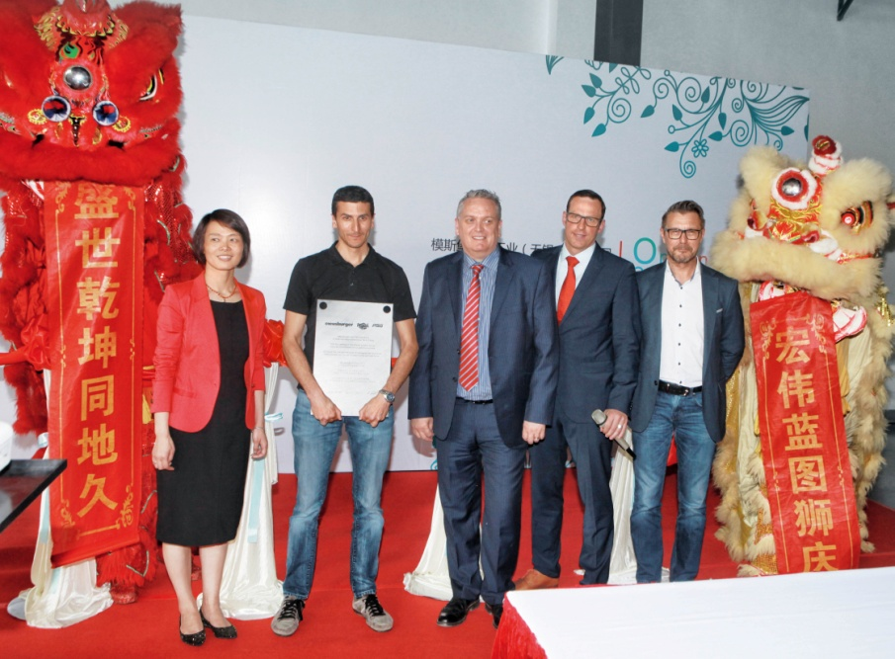

Right to left:

Haifang Wei (CFO Meusburger Mould and Die (Wuxi) Co., Ltd)
Daniel Fuchs (Member of the Executive Board, Director Logistics & Purchasing, Meusburger)
Adrian Low (CEO Meusburger Mould and Die (Wuxi) Co., Ltd)
Udo Fuchslocher (CEO PSG)
Stefan Dür (Head of Sales, Meusburger)

Meusburger Group – Setting Standards

The Meusburger Group is the leading international manufacturer of high-quality standard parts, hot runner and control systems and selected items in workshop equipment. More than 17,500 customers all over the world make use of the numerous advantages of standardisation and benefit from the company's over 50 years of experience in working with steel. The permanent availability of products makes the Meusburger Group the reliable and global partner for die, mould, jigs and fixtures construction.

Further information:
Meusburger Georg GmbH & Co KG
Communication / Public relations
Lia Klimmer
Phone: + 43 5574 6706-1446
Email: presse@meusburger.compresse@meusburger.com
www.meusburger.com/press-releases

