Press Release
Wolfurt, on 10. December 2020

The right plate for every project

At Meusburger, customers will not only find a very large selection of high-quality P-Standard plates, but also P-Special plates in variable dimensions and various versions. All plates are of course heat-treated for stress relief and machined to very tight tolerances.

Thanks to their 18,000 m² warehouse, Meusburger has a very large selection of P-Standard plates. In addition, the market leader in the area of high-precision standard parts offers special plates with flexible dimensions and various designs. This guarantees that every customer will find the right plate for every project, no matter how specialised. And these are heat-treated for stress relief and in the usual high quality.

High price reliability and short lead time
To ensure that the right range of P-Standard plates for all customers is available, Meusburger reacts quickly to developments on the market and constantly expands their range with sizes in demand. Customers benefit from the P-Standard plates from Meusburger in several ways. P-Standard plates can be ordered in the web shop or also in the offline shop with just a few clicks, and the price display before ordering means that the customers can be sure of exactly what they are spending.
The plates are milled in width and length and segment ground in the thickness. They are available in numerous sizes and materials directly from stock. The resulting short lead time guarantees the customer absolute planning security for all projects. Since Meusburger stores the heat-treated for stress relief plates for their customers on a total of 18,000 m², important warehouse space can also be saved.

Flexibility in all areas
In addition to the P-Standard plates, Meusburger also offers customers maximum flexibility with the P-Special plates. With many different versions and variable dimensions, customers have the option of ordering plates customised to the respective project. Despite special machining, Meusburger guarantees fast delivery even for P-Special plates thanks to its modern machinery.
Since each individual plate in a special plates order is manufactured according to the customer’s requests, the price for each order is recalculated after entering the dimensions, design and material. If a P-Special plate requested by a customer is available from stock as a P-Standard plate, the order is automatically converted to a P-Standard plate.

This goes to show that regardless of whether one of the common sizes of the P-Standard plates is suitable, or more flexibility is required - Meusburger has the right plate for every project. Further information about the variety of plates at Meusburger can be found at: www.meusburger.com.

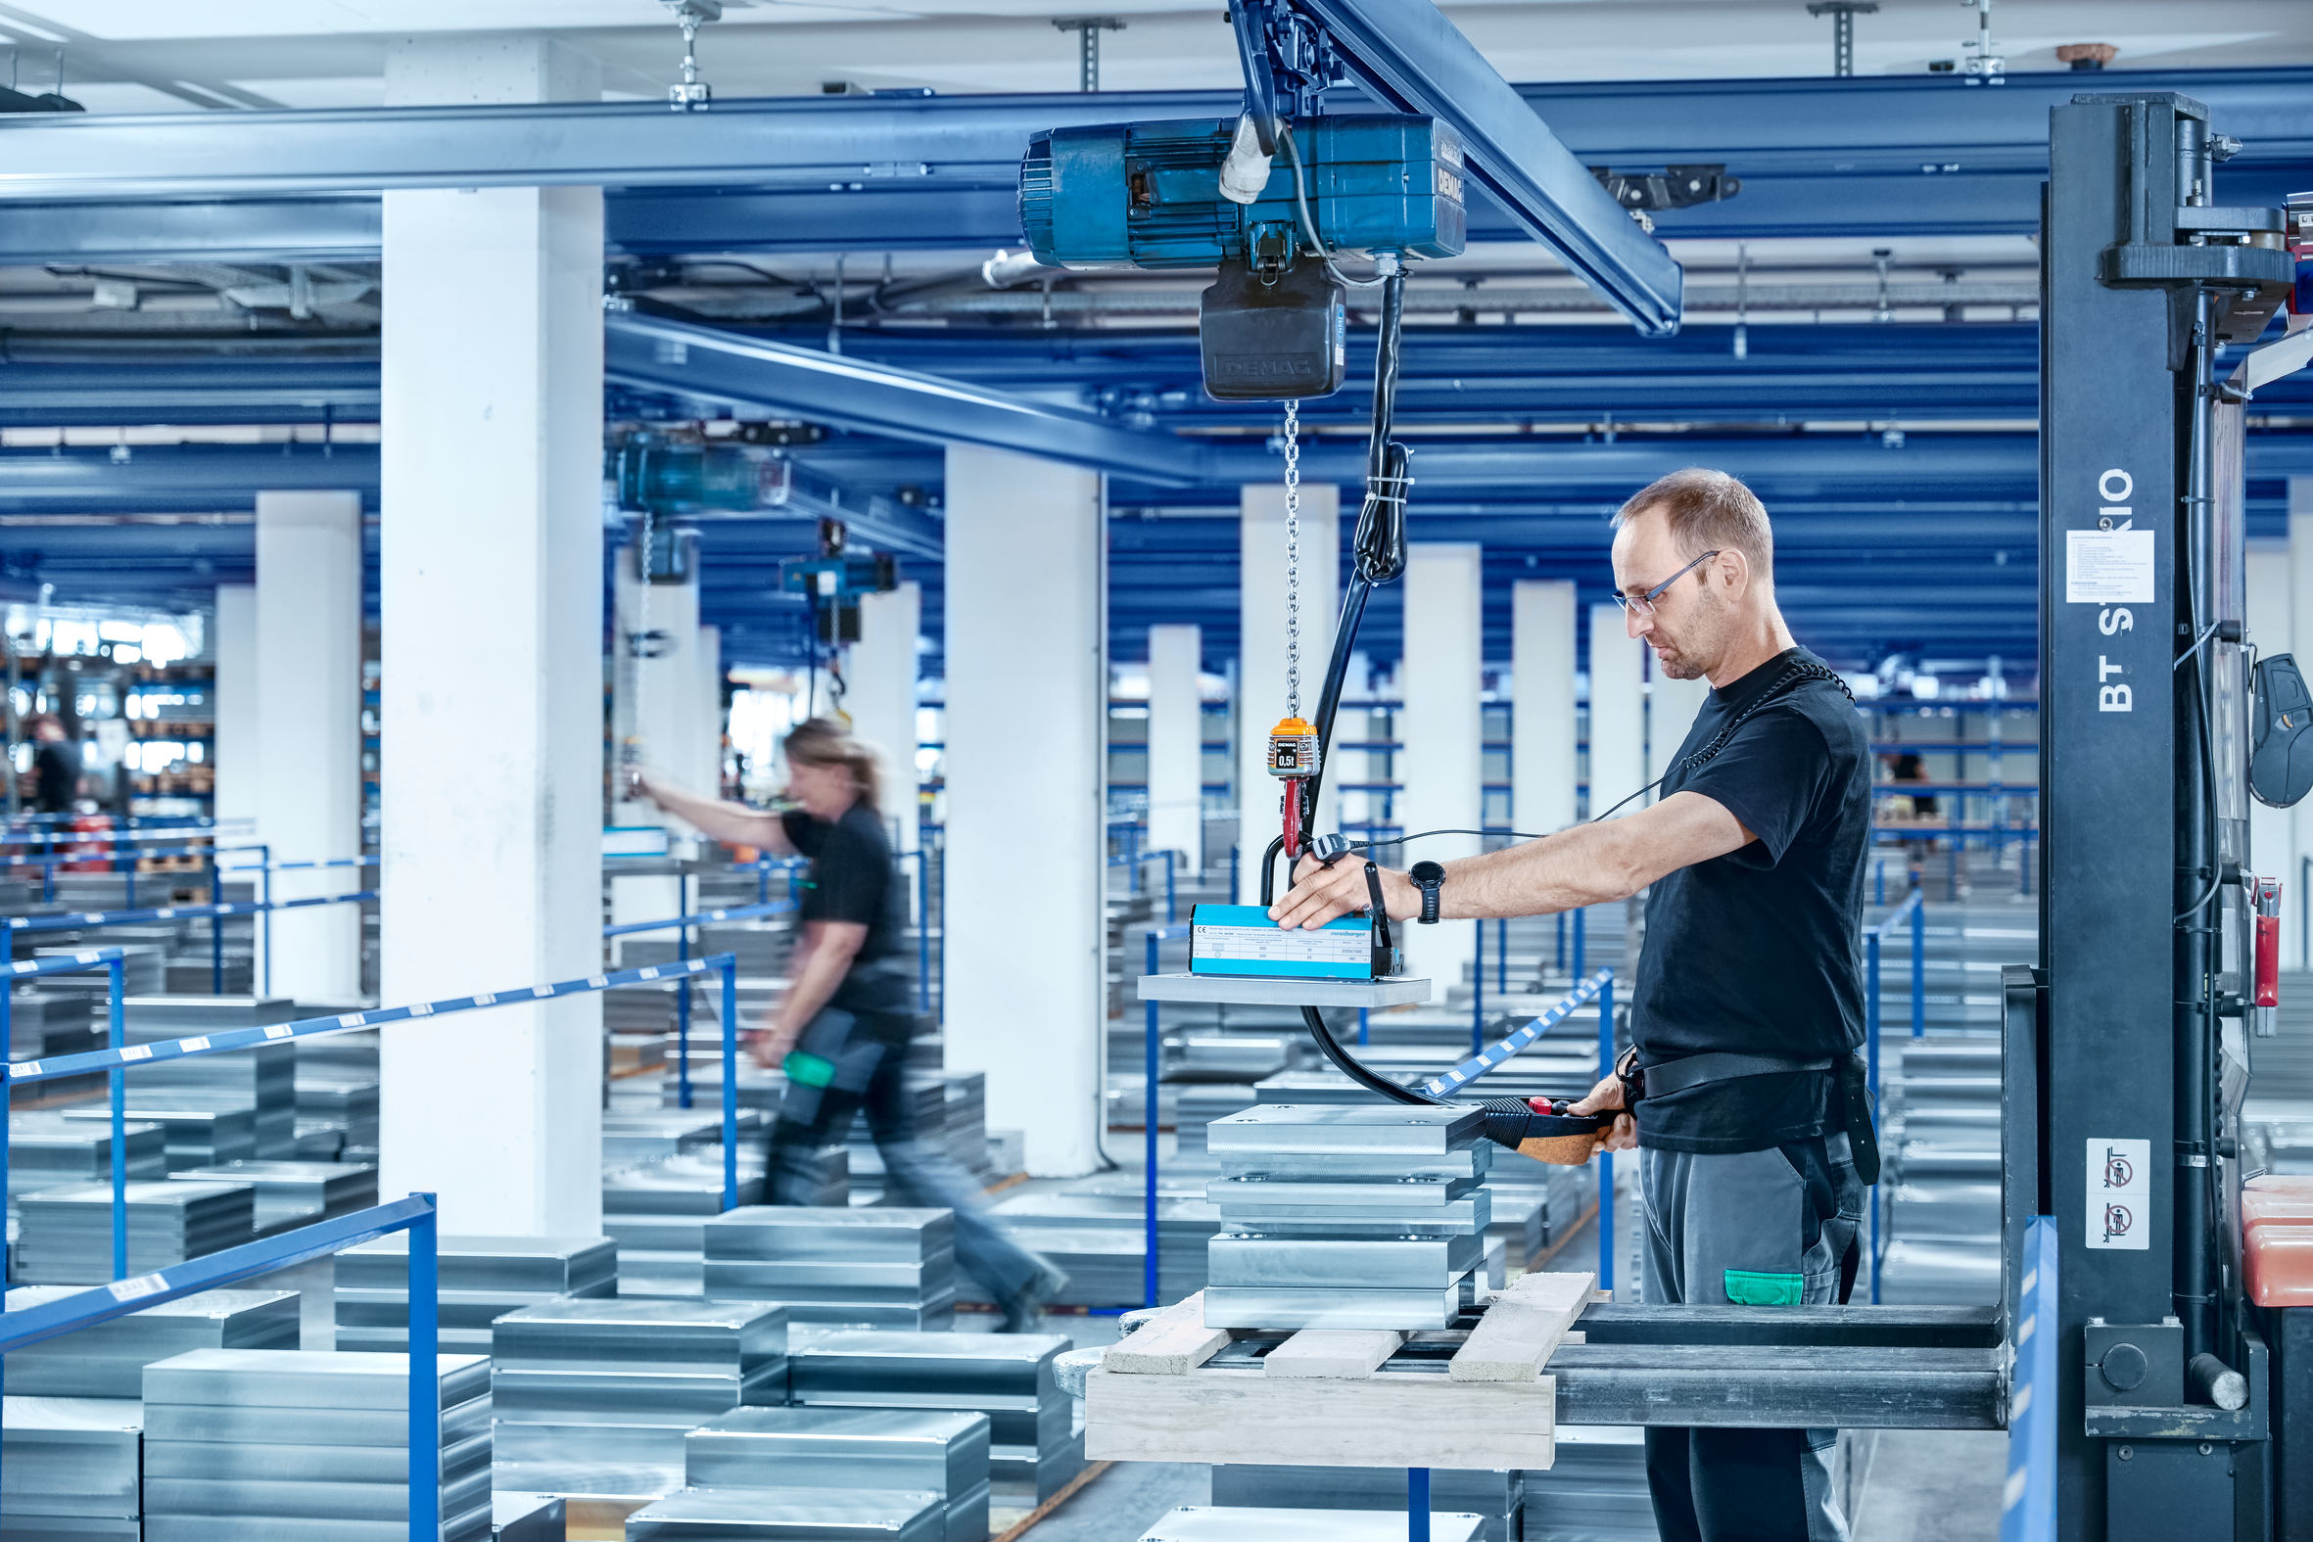
Image source: Meusburger
Caption: Meusburger has the right plate for every project.

Meusburger – Setting Standards.

As a part of the Meusburger Group, the Meusburger company is the market leader in the field of high-precision standard parts. 21,000 customers all over the world make use of the advantages of standardisation and benefit from the company's over 50 years of experience in working with steel. Offering an extensive range of standard parts, combined with selected products in the field of workshop equipment, Meusburger is the reliable global partner for making moulds, dies, jigs and fixtures.

Press contact

Meusburger Georg GmbH & Co KG
Communication / Public relations
Phone: +43 5574 6706-0
Email: presse@meusburger.com
www.meusburger.com

