Meusburger Georg GmbH & Co KG
Kesselstr. 42, 6960 Wolfurt, Austria

The Meusburger Group is represented at the Fakuma 2018

From the 16th to the 20th of October 2018, the Meusburger Group will be represented at the international trade fair for the processing of plastics in hall A2 at stand 2313 and 2317. With the motto ‘everything from a single source’, Meusburger, PSG, WBI and the youngest group member, Segoni will present new and tried and trusted products and services in the field of mould and die making.

Mould makers can see many innovations at the Meusburger trade fair stand, such as the build-in cylinder for the smallest installation spaces or the smallest ready-to-use slide unit available on the market. Comprehensive additions to the range of stainless steel products - which are particularly suitable for applications in clean room technology - will also be presented. In the newly created presentation corner, short keynote speeches on exciting topics will be held. Of course, the tried and trusted Meusburger classics including the multifunctional H 1000 Clamping system which ensures high efficiency through precise and repeatable clamping of moulding plates in the µ range, and the innovative H 4062 Assembly table which makes it possible to move the mould halves easily by way of multiple air nozzles - will be presented as well.

Hot runner and control systems
The hot runner and control systems manufacturer PSG will be presenting innovative solutions for all kinds of injection moulding applications at the stand next to ours. In the field of hot runners, the company has been providing customer specific solutions for over 50 years which feature reduced cycle times, rapid colour changes, dimensional stability, gating of difficult to reach parts, shortest sealing times, and small cavity distances. One of the highlights in terms of control systems is the new variant of the profiTEMP+ hot runner controller with up to 192 control zones, which features innovative technology and space-saving design. In addition to intelligent functions like Smart Power Limitation (SPL) and MoldCheck, the tried and trusted features are also integrated. The clearly designed multi-touch screen is especially easy and intuitive to use.

Securing knowledge with WBI Knowledge Management
Also at the Meusburger stand is a team from WBI Knowledge Management. WBI – Better Integration of Knowledge – is a simple, pragmatic method of knowledge management, which is based on over 25 years of development and experience at Meusburger. It links people, organisation and technology and can be adapted to any company in any industry. The experts at WBI are happy to advise interested parties about the complete package for the simple management of knowledge, comprising of the WBI method, the suitable software, and the content. On request, they accompany customers from the very start of the project through to its implementation in their own company. The second and extended edition of the book ‘Corporate Management with Knowledge Management’ by Guntram Meusburger will also be presented for the first time at the trade fair.

The future is digital…
...and this is reason enough for the Meusburger Group to increasingly focus on the subject of digitalisation. Segoni is the youngest member of the Meusburger Group and offers ERP/PPS software solutions for efficient production planning for companies with individual production structures in the fields of mould, die, and jigs and fixtures construction. The fully customised products and services enable a rapid introduction and efficient operation for digital mapping of business processes. Segoni PPMS is a fully integrated ERP solution that includes everything to do with calculation, deadline and capacity planning as well as purchasing and management. At the Meusburger stand, the manufacturer will present a live demo of the current software version and provide information about the benefits and possibilities of the system.

Take a look behind the scenes at Meusburger
Since the Fakuma takes place very close to the main headquarters of the expert in standard components, company tours are offered several times a day during the trade fair for those interested. Registration for the exciting glimpse behind the scenes is possible until the end of September by email to m.koch@meusburger.com.

Picture credits: Photo (Meusburger)
Caption: The Meusburger Group presents tried and trusted as well as new products at the Fakuma 2018

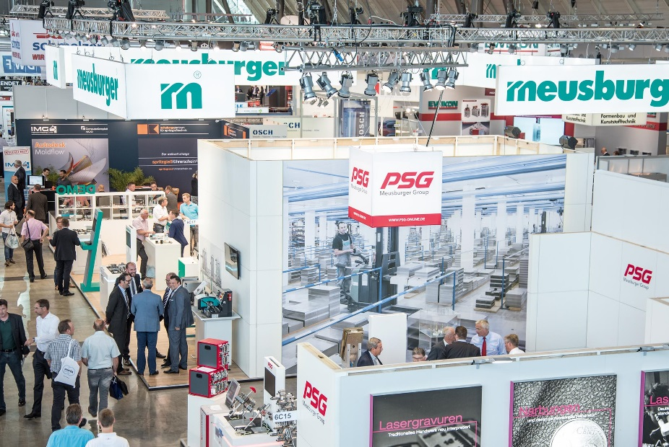

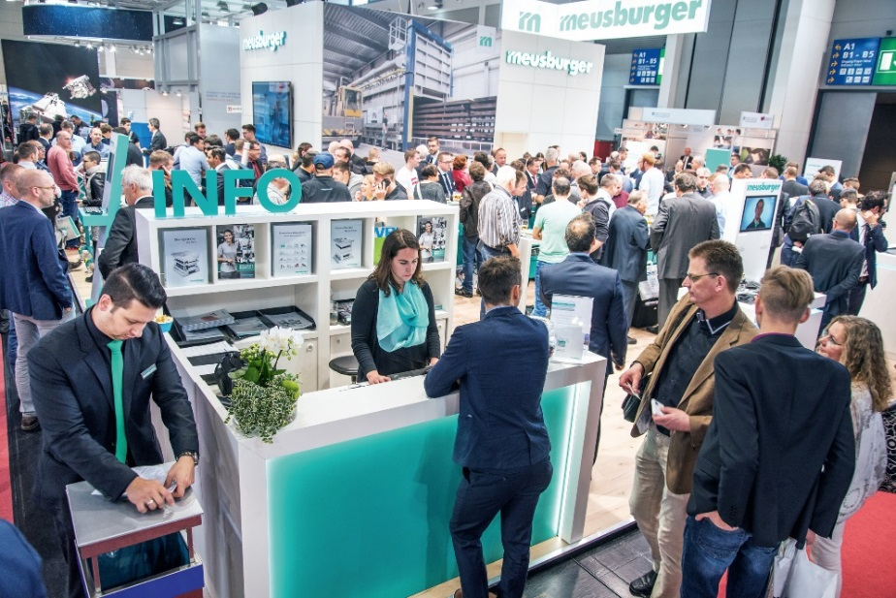

Meusburger Group – Setting Standards

The Meusburger Group is the leading international manufacturer of high-quality products for mould, die, and jigs and fixtures construction. The continuous availability of all products makes us the powerful and reliable partner in the industry. We help our customers to achieve sustainable success along the entire value chain. With us, they are able to efficiently manufacture moulds and dies as well as jigs and fixtures with the shortest lead times and constant high quality.

Further information:
Meusburger Georg GmbH & Co KG
Communication / Public relations
Eveline Steurer
Phone: + 43 5574 6706-1471
Email: press@meusburger.compresse@meusburger.com
http://www.meusburger.com/en/press/press.html

