PRESS RELEASE
Wolfurt, on 20.08.2019

Meusburger at the K 2019 with market innovations

At this year’s K trade fair in Düsseldorf (16 to 23 October), the Meusburger stand (hall 1, stand C30) will feature the new and one-of-a-kind configurator for hot runner moulds. In addition, the new cavity pressure sensors and many other Meusburger products will be presented. Of course the divisions of hot runner and control systems, Knowledge Management, and ERP will also be presented.

A special highlight at this year’s K 2019 is the new configurator for hot runner moulds, which is offered exclusively in cooperation between Meusburger and PSG. The complete mould base including hot runner manifold can be customised with just a few clicks and shipped shortly thereafter in the usual high quality in just one order. In addition to the hot runner mould, the required components and the right accessories can also be ordered directly from Meusburger. This way the customer receives everything from just one source and with only one order.

New sensors for more process reliability
As a second product highlight, Meusburger presents the new and immediately available cavity pressure sensors, with which the company is taking a further step towards industry 4.0. These offer maximum flexibility through direct or indirect cavity pressure measurement and are compatible with all common piezoelectric pressure sensors. The smallest installation spaces also ensure a high degree of freedom in the mould design. These innovations and many more Meusburger products can be viewed and tested at stand C30.

Everything from a single source
In addition to Meusburger, PSG, WBI, and Segoni will also be presenting their range of products for mould and die making. The hot runner and control systems manufacturer PSG will be presenting innovative solutions for all aspects of injection moulding. In the hot runner division, the company continues to impress with customer specific solutions when it comes to reduced cycle times, rapid colour changes, and gating of difficult to reach parts. In control systems, the main focus is the profiTEMP+ hot runner controller which features space-saving design in addition to state-of-the-art technology.

Digitalisation has arrived
WBI Knowledge Management will also be represented at the Meusburger stand and will present their specially developed software for knowledge management. With this software, the resource of knowledge can be collected, shared, further developed and saved thus preventing the loss of important know-how.
In addition, Segoni will offer a live presentation of the latest version of their software for efficient production planning for companies with individual production structures in the fields of mould, die, and jigs and fixtures construction. They will also provide information for visitors on the use and capabilities of the system.

Further information: www.meusburger.com

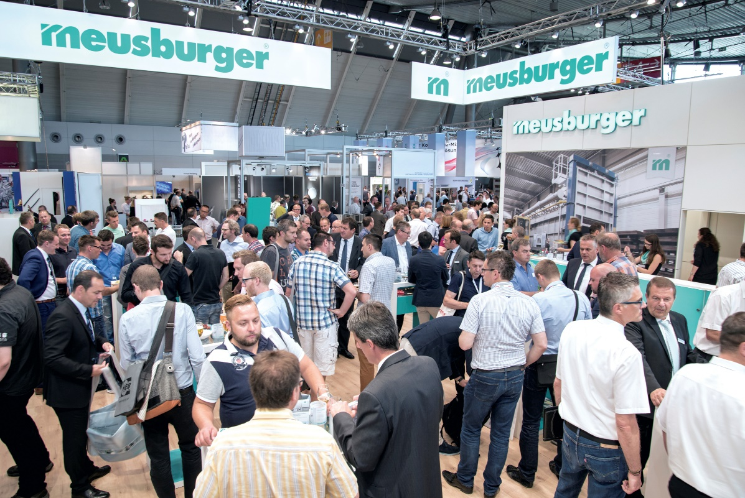

Image source: Meusburger, publication free of charge publication free of charge
Caption: The Meusburger Group presents tried and trusted as well as new products at the K 2019

Meusburger – Setting Standards.

As a part of the Meusburger Group, the Meusburger company is the market leader in the field of high-precision standard parts. Worldwide, 21,000 customers make use of the advantages of standardisation and benefit from the company's over 50 years of experience in working with steel. Offering an extensive range of standard parts, combined with selected products in the field of workshop equipment, Meusburger is the reliable global partner for making moulds, dies, jigs and fixtures.

Press contact

Meusburger Georg GmbH & Co KG
Communication / Public relations
Phone: +43 5574 6706-0
Email: press@meusburger.com
www.meusburger.com

