Meusburger Georg GmbH & Co KG
Kesselstr. 42, 6960 Wolfurt, Austria

Meusburger highlights at the Blechexpo trade fair

The Austrian expert in standard components is again presenting many innovations for die making at the Blechexpo trade fair in Stuttgart. The entire range of components with around 8,500 items can be found in the new clearly arranged 2018 I 2019 catalogue. Innovative active parts and the revolutionary H 3000 Clamping system are brand new in the Meusburger range. There are also interesting expansions for cutting elements and the blocks for eroding.

New products for die makers
As of mid October, numerous innovations for die making are available at Meusburger. The new products – namely different active parts, new cutting elements as well as expansions in the area of blocks for eroding – will be presented at Blechexpo 2017 at the Meusburger stand 7108 in hall 7 for the first time. Take the opportunity to have a closer look at the innovations and try them out on the spot!

H 3000 – an innovative in-house development
For many years, mould makers have already known the multifunctional H 1000 Clamping system which has revolutionised the manufacturing process in mould making and stands for high efficiency. Now the innovative system is also available for die makers as the ‘H 3000’. The clamping system was designed and constructed to exactly match the standard hole pattern of the Meusburger die sets. The H 3000 is an innovative in-house development from Meusburger. The high precision of the H 3000 in combination with the high accuracy of the Meusburger standard die sets result in an exact and dimensionally perfect stamping die. Due to very tight tolerances of the mounting holes and the clamping elements, the die plates can be clamped and machined with repeatable accuracy in the µ range with the help of the Meusburger H 3000 Clamping system. As a result, time and costs can be saved in this production.

Clearly arranged catalogue with practical selection guides
In addition to different die sets, the leading manufacturer of high-precision standard parts also offers its customers a wide range of components especially for die making. The complete range of components with around 8,500 items is clearly arranged on 450 pages in the new catalogue ‘Die Making Components 2018 I 2019’. The practical selection guide and technical information provided in the catalogue make it user-friendly and facilitate the user’s everyday work. Highlights include innovative active parts for guiding, positioning, and machining of metal strips, a wide range of configurable cutting elements as well as gas springs with active safety devices. The new catalogue can be ordered directly at the Meusburger stand at the Blechexpo.

Visit Meusburger at the Blechexpo trade fair: in hall 7 at stand E 7108

Further information: www.meusburger.com

Picture credits: Photo (Meusburger)
Caption: The Meusburger stand is always worth a visit

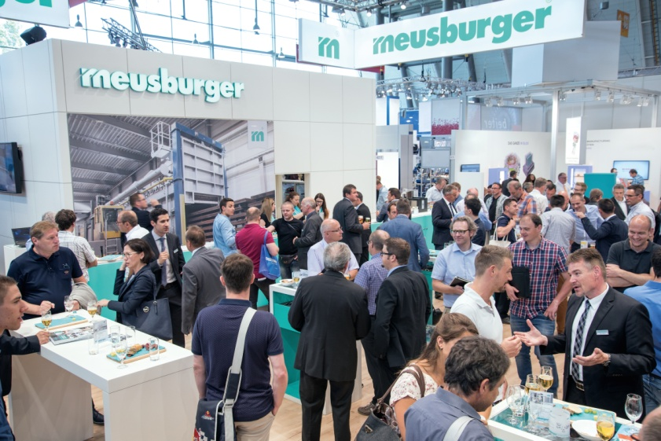

Meusburger Group – Setting Standards

The Meusburger Group is the leading international manufacturer of high-quality standard parts, hot runner and control systems and selected items in workshop equipment. More than 17,500 customers all over the world make use of the numerous advantages of standardisation and benefit from the company's over 50 years of experience in working with steel. The permanent availability of products makes the Meusburger Group the reliable and global partner for die, mould, jigs and fixtures construction.

Further information:
Meusburger Georg GmbH & Co KG
Communication / Public relations
Lia Klimmer
Phone: + 43 5574 6706-1446
Email: presse@meusburger.compresse@meusburger.com
http://www.meusburger.com/press-releases

