PRESS RELEASE
Wolfurt, on 06.11.2019

New products for hot runner and control systems
Meusburger presents innovations in the field of hot runner and control systems. Under the PSG product brand, the number of versions of the smartFILL nozzle series has been expanded with a new focus. The range is perfectly complemented by the pneumatic and hydraulic operating unit for valve gate nozzles. In control systems, the combination of a VCON controller with the profiTEMP+ in one cabinet has been made possible.

The newly developed series focuses on melt guidance and ease of maintenance. With the very large variety of nozzle lengths, melt channel diameters and gate geometries, the smartFILL nozzle series is now also available in the large 4557 and the small 4019 versions. The nozzles are available in the variations smartFILL (slide seal), smartFILL Shot (screwed in) or smartFILL Shot Single (single application). They are not only suitable for processing technical and filled plastic types, but also for direct gating or gating to a cold runner. The new concept of heating right up to the injection point ensures a homogeneous temperature profile, which in turn guarantees highest component quality.

Further product highlights:
- Fast and easy heater change thanks to spiral/wedge clamping
- Small cavity distances possible due to small fitting dimension Ø19
- Hot runner nozzles can be used for shot weights from 0.5 g up to 2,500 g
- All gate types available: ring gate RT, DRT, DRT-L and valve gate NZ, DNZ, DNZ-L

Compact redevelopment
Compatible with the smartFILL nozzle series, the pneumatic (DP 53x63) and hydraulic (MH 24x55) operating units for valve gate nozzles are new in the range. With the pneumatic operating unit, the pin is opened and closed via the clamping plate using compressed air. Even with individual actuation of each nozzle, tight inside dimensions are possible for both units. This makes these operating units particularly suitable for use in conjunction with the 19 and 27 nozzle sizes in the smartFILL series.
Further product highlights:
- Flange-mounted and cooled hydraulic operating unit (MH 24x55)
- Precise pin positioning via a vernier scale, which results in hardly visible injection points and improved reproducibility of injection point quality
- Valve pin secured against twisting as standard (MH 24x55)

All options in one cabinet
Achieve optimum injection moulding results through sequential control of the melt flow. During the opening or closing of the valve pin, it is possible to control the various pin positions hydraulically in staggered modes. For cascaded filling of injection moulded parts with several injection points, visible defects on moulded parts can be avoided this way.

Further product highlights:
- Simple and inexpensive changeover from hydraulic hot runner systems to varioFILL advanced
- profiTEMP+ VCON: VCON controller can be combined with a hot runner control device in one cabinet
- Integrated handling of temperature and cascade control
- Intuitive touch screen operation

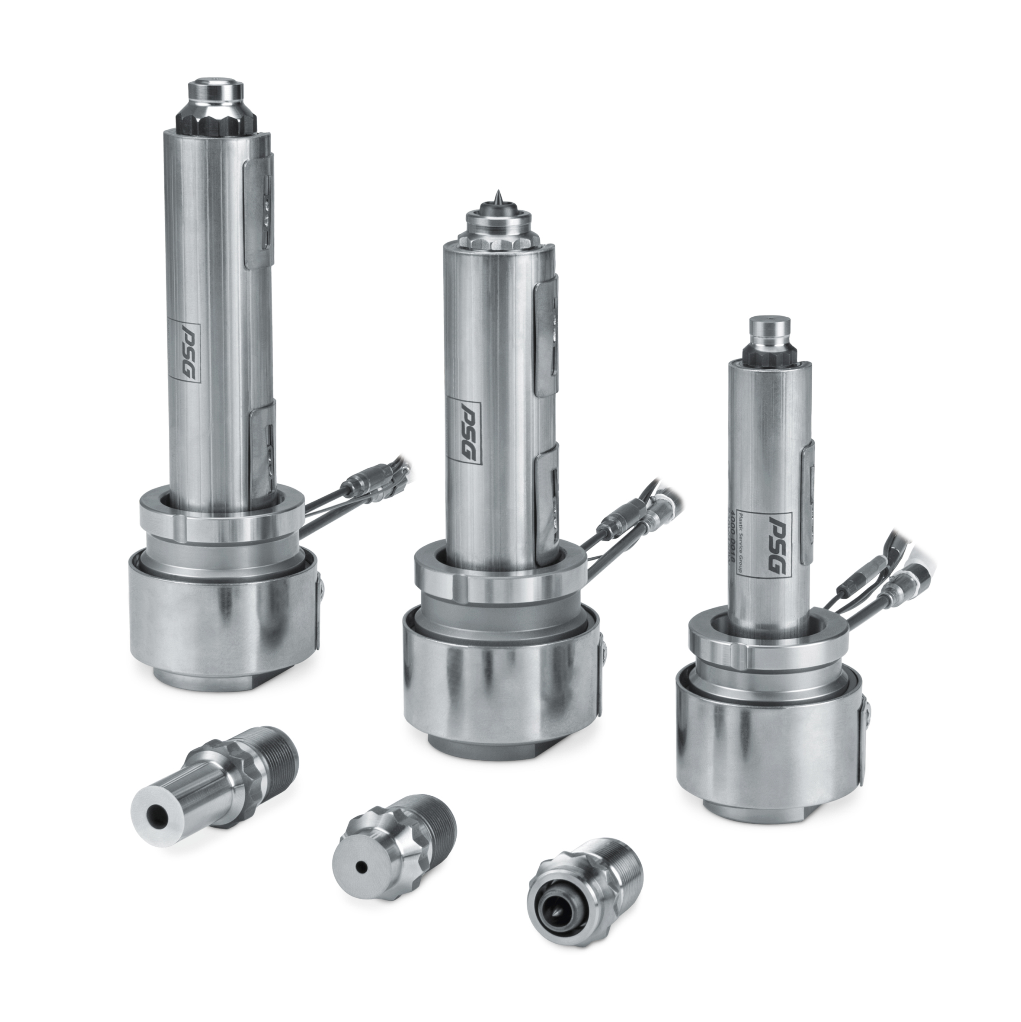
Caption: smartFILL nozzle series now with new variations

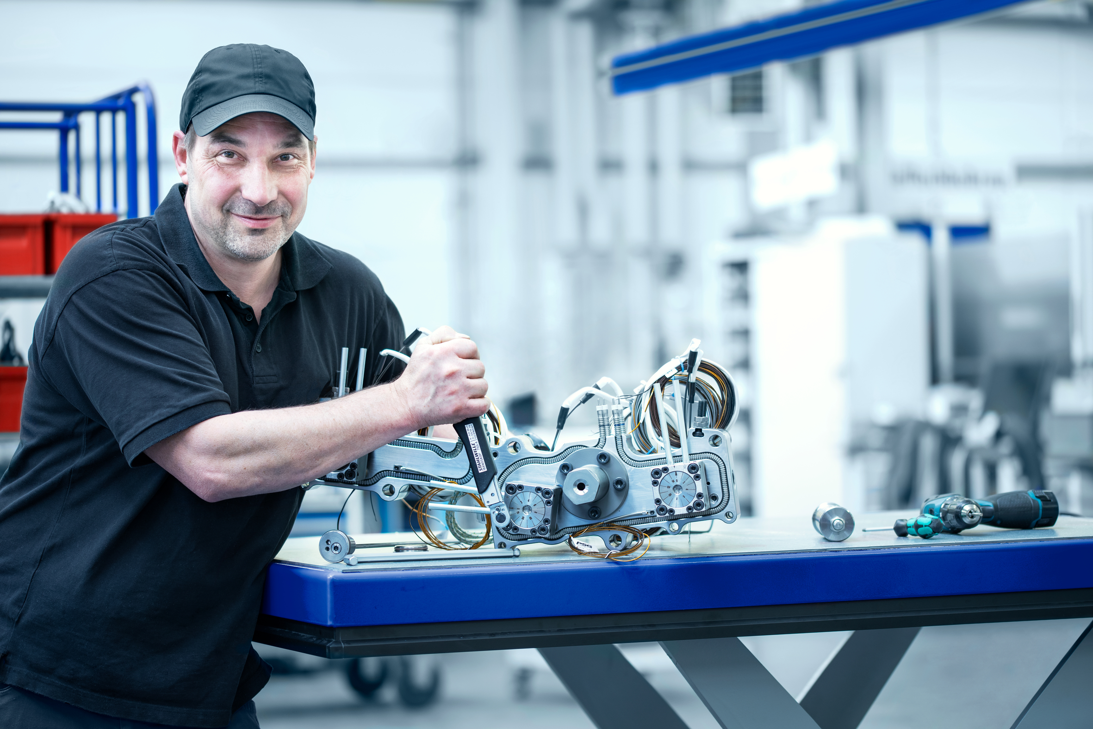
Caption: Redevelopment of operating units for valve gate nozzles

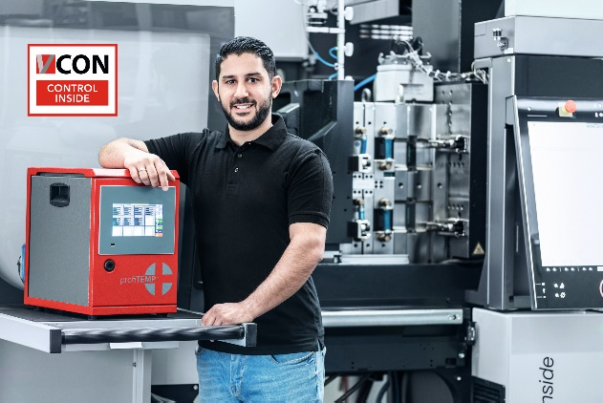
Caption: VCON controller combinable in one cabinet with the profiTEMP+

Press contact

Meusburger Georg GmbH & Co KG
Communication / Public relations
Phone: +43 5574 6706-0
Email: press@meusburger.com
www.meusburger.com

