Meusburger Georg GmbH & Co KG
Kesselstr. 42, 6960 Wolfurt, Austria

Increased stamping process reliability with precision control devices

Continuous monitoring of the stamping process is essential for modern die making. Meusburger, the expert in standard components, expands its product range of tried and trusted fork light barriers and adds further components for secure and reliable process monitoring.

Feed and positioning control
Alongside the tried and trusted E 6530, E 6532 and E 6536 Fork light barriers in infrared light and red light variation, Meusburger now offers an E 6534 Split light barrier for feed and position control. Thanks to its compact design, this component requires very little space. The distance between the sender and the receiver can easily be varied, enabling a flexible installation. The E 6548 Alternating light amplifier serves to strengthen the sensor signal.

Double sheet detection and tilt control
Non-contact distance measurements can be made with the inductive E 6540 Analogue sensor. For further processing of the sensor signal, the analogue sensor is connected with the E 6541 Analogue controller. Up to 4 analogue sensors can be connected to the controller, and can be set up independently of each other and then routed to an outlet. The advantage here is that only one inlet is used on the tool monitoring devices.

Ejection control
The new E 6538 Multibeam fork light barrier has a ‘light band’ that consists of several light beams. As soon as one or more of these light beams are interrupted, a signal is generated. They work dynamically to enable accurate ejection control. This guarantees a defined and adjustable signal output regardless of the interruption duration.

As usual the Meusburger light barriers are available from stock.

Picture credits: Photo (Meusburger)
Caption: Increased process reliability in the stamping process with precision control devices
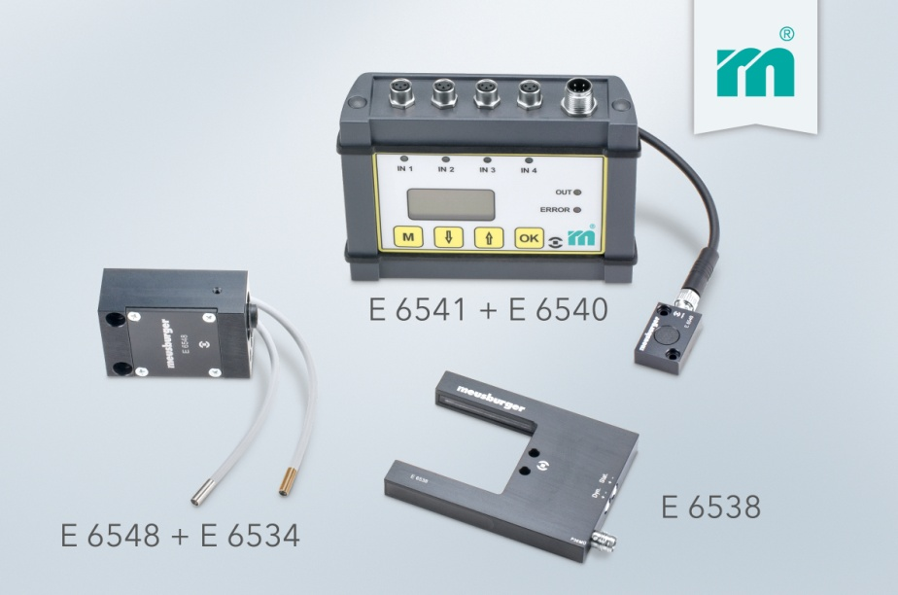

Meusburger Group – Setting Standards

The Meusburger Group is the leading international manufacturer of high-quality standard parts, hot runner and control systems and selected items in workshop equipment. More than 18,500 customers all over the world make use of the numerous advantages of standardisation and benefit from the company's over 50 years of experience in working with steel. The permanent availability of products makes the Meusburger Group the reliable and global partner for die, mould, and jigs and fixtures construction.

Further information:
Meusburger Georg GmbH & Co KG
Communication / Public relations
Lia Klimmer
Phone: + 43 5574 6706-1446
Email: press@meusburger.compresse@meusburger.com
http://www.meusburger.com/en/press/press.html

