Meusburger Georg GmbH & Co KG
Kesselstr. 42, 6960 Wolfurt, Austria

Meusburger: 5,000 new plates and bars sizes

In October 2018, Meusburger expanded its product range with more than 5,000 new sizes of heat-treated for stress relief standard plates and bars, in order to offer customers in the field of mould, die, and jigs and fixtures construction a comprehensive range of products.

The standard bars are available in many new dimensions, from 20x300 to 800x1200 – as standard, sawn in width and length and segment ground in thickness. Numerous round bars with turned or ground diameters and sawn to length are also new to the range and now available in lengths from 16 to 1500 mm. Additionally, many intermediate sizes have been added. Also the tried and trusted standard plates which in comparison to the bars are milled in width and length, are now available in many new dimensions. The entire range of standard plates and bars is as usual available from stock in the Meusburger web shop.
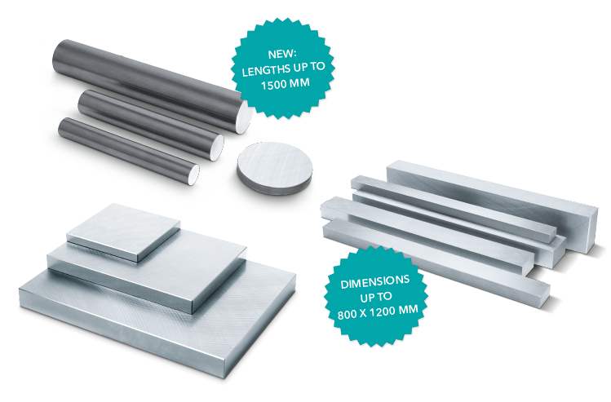

Picture credits: Photo (Meusburger)
Caption: Extensive additions to the product range of P-Plates, N-Bars, and NR-Bars which are the optimal starting material for any application in mould, die, and jigs and fixtures construction.

Meusburger – Setting Standards

As a part of the Meusburger Group, the Meusburger company is the market leader in the field of high-precision standard parts. Customers all over the world make use of the advantages of standardisation and benefit from the company's over 50 years of experience in working with steel. Offering an extensive range of standard parts, combined with selected products in the field of workshop equipment, Meusburger is the reliable global partner for making moulds, dies, jigs and fixtures.

Further information:
Meusburger Georg GmbH & Co KG
Communication / Public relations
Phone: + 43 5574 6706-0
Email: press@meusburger.compresse@meusburger.com
http://www.meusburger.com/en/press/press.html

