Meusburger Group takes over Segoni

Wolfurt/Austria. The internationally active Meusburger Group with headquarters in Wolfurt will be taking over Segoni. The Berlin software specialist will continue as an independent enterprise, and all employees will be retained. In the coming years, long-term investments will be made in the further development of the software. Alongside the knowledge-based management method WBI, customers of the Meusburger Group will also be supported in the area of ERP/PPS through the digitalisation process.

The Meusburger Group, internationally leading manufacturer of high-quality standard components, products for hot runner and control systems as well as selected articles for workshop equipment, is taking over Segoni. Segoni, market leader in the field of ERP/PPS software for medium-sized companies in Germany/Austria/Switzerland, will continue as an independent enterprise. The Meusburger Group will continue in the direction already taken by Segoni and make long-term investments in the further development of the software.

Understanding customers even better
This shows that alongside the existing areas of business, the Meusburger Group is also engaging strongly with the topic of digitalisation. The goal is to understand our customers and their processes even better, in order to then be able to optimise processes together. Alongside the already tried and trusted knowledge-based management method WBI (Better Integration of Knowledge), thanks to the takeover of Segoni, customers of the Meusburger Group will in future also have extensive support through the digitalisation process in the areas of ERP (Enterprise Resource Planning) and PPS (Production Planning and Control System).

Further development of the Segoni software
Segoni is active in Germany, Austria and Switzerland in the area of ERP/PPS software for medium-sized companies. Their many customers are manufacturing companies with individual production structures, from the areas of mould, die, and jigs and fixtures construction. Segoni offers solutions for efficient corporate management. The range of products and services are tailored to the requirements of the companies and contain everything to do with planning, calculation, deadline and capacity planning, as well as purchasing and warehouse management.
‘With Segoni we are bringing on board the leading supplier in the field of ERP/PPS software for medium-sized companies in our industry. In the years to come we will invest in the further development of the software and through this continuously and sustainably expand the range of services we offer our customers’ explains Guntram Meusburger, Managing Director of the Meusburger Group.

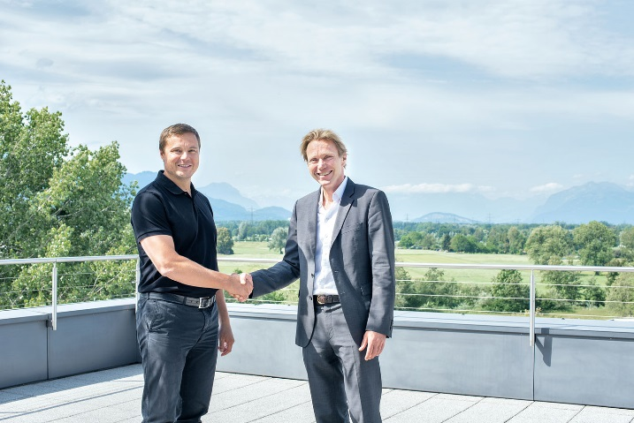
Caption: Guntram Meusburger (l.) and Roland Schmid (Segoni) are looking forward to a successful partnership.
Photo source: Meusburger

Meusburger – Setting Standards.
The Meusburger Group is the internationally leading manufacturer of high-quality products for mould, die, and jigs and fixtures construction. Constant availability of all products makes us the powerful and reliable partner in the industry. We help our customers to achieve sustainable success along the entire value chain. With us you are able to efficiently manufacture moulds, dies, machines, and jigs and fixtures with the shortest lead times and constant high quality.

Further information:
Meusburger Georg GmbH & Co KG
Lukas Österle
Communication / Public relations
Phone: + 43 5574 6706-1736
Email: presse@meusburger.com

