Meusburger Georg GmbH & Co KG
Kesselstr. 42, 6960 Wolfurt, Austria

Reliable clamping with Meusburger high-pressure clamping equipment

The standard parts manufacturer Meusburger expands its range of workshop equipment especially coordinated to die and mould making with high-quality high-pressure clamping equipment. In addition to the tried and trusted centring vices Meusburger now offers high-pressure vices in three different variations. Due to the integrated power amplifier a clamping force of up to 50 kN is reached. The repeatable accuracy during clamping is 0.01 and enables highest precision in the machining of workpieces.

HWS 650 and HWS 600 – the high-pressure mechanical vices
The stable monoblock bodies from GGG-70 are especially compact and maintain their total length even with different workpiece dimensions. Due to the fully enclosed spindle and the additional side window the effort for cleaning these two high-pressure vices is reduced to a minimum. The HWS 600 is equipped with a pull-down clamping system which prevents the lifting of the clamped workpiece. All of the model’s surfaces are ground with a parallelism of 0.02 mm making it especially suitable for horizontal and vertical machining. The HWS 650 High-pressure mechanical vice is ideal for use on CNC milling centres and also offers the possibility to rotate the jaws 180° degrees, by which a large clamping field is reached. The suitable accessories for specific applications, for example different clamping jaws, can be selected in the online catalogue.

HWS 500 – the robust, mechanical high-pressure machine vice
The new HWS 500 model uses 100% of the clamping force due to the centrally positioned spindle with mechanical high-pressure amplifier. The robust monoblock body from GGG-70 ductile cast iron offers high stability and is suitable for universal applications in die and mould making. The hardened and ground guiding surfaces provide for highest precision during clamping. Meusburger also offers the appropriate accessories for this product like different clamping jaws, an individually adjustable stop for protruding workpieces as well as a rotary base for flexible positioning of the machine vice.

The entire range of high-pressure clamping equipment is now available from stock at Meusburger.

Picture credits: Photo (Meusburger)
Caption: New: Meusburger high-pressure clamping equipment

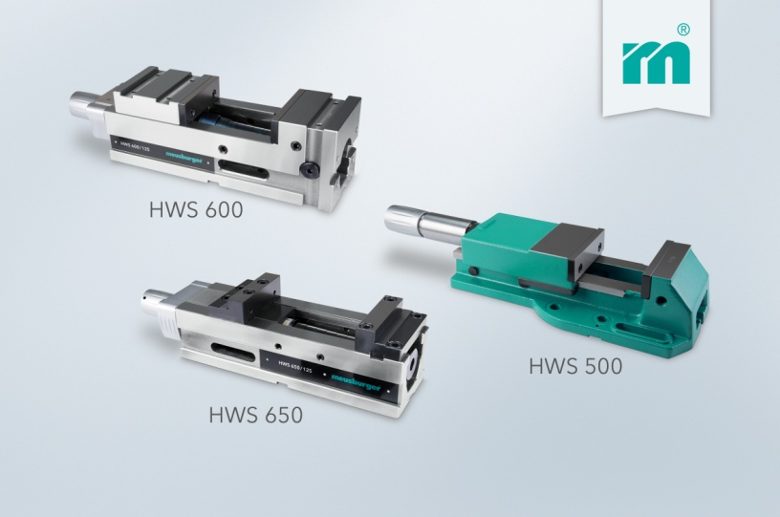

Meusburger Group – Setting Standards
The Meusburger Group is the leading international manufacturer of high-quality standard parts, hot runner and control systems and selected workshop equipment. More than 17,500 customers all over the world make use of the numerous advantages of standardisation and benefit from the company's over 50 years of experience in working with steel. The permanent availability of products makes Meusburger the reliable global partner for making dies, moulds, jigs and fixtures.

Further information:
Meusburger Georg GmbH & Co KG
Communication / Public relations
Lia Klimmer
Phone: +43 5574 6706-1446
Email: press@meusburger.com
www.meusburger.com/press-releases

