Meusburger Georg GmbH & Co KG
Kesselstr. 42, 6960 Wolfurt, Austria

Outsourcing Instead of Self Made –
Efficiency in Machine and Jig construction

Since the introduction of the area of business 'Jigs and Fixtures' the standard parts manufacturer Meusburger has recorded a steady growth in customer clientèle who build on the quality and the reliability of immediately available standard components. The trend towards standardisation is taking more and more hold in machine and jig construction. A logical development, considering that increasingly shorter project lead times and efficiency improvements are required in order to survive on the international market with the progressing globalisation.

Ordered today – immediately dispatched
We will show you a concrete example of the advantages of prefabricated components. For the production of the pictured milling fixture lots of steel is needed. Semi-finished products from Meusburger offer a cost effective alternative to steel trading. All plates and bars are already precision prefabricated, available from stock and are delivered free of charge within 24 hours to Germany, Austria and Switzerland and within 5 – 7 days to the rest of Europe. Calculation and design are quick and easy with the help of the Meusburger online catalogue. Flame-cut blanks and milling operations are provided upon request. Therefore the customer saves resources and can concentrate on his core competence.

Lowering tension
During the production of steel plates tension grows in the material from various machining processes – caused, for example, by irregular temperature. When the steel cools in the rolling mill tension remains in the material which can lead to unpredictable warping in subsequent machining.
To prevent this Meusburger heat treats the material in one of its three furnaces according to a specially defined heat treatment chart. The temperature is below the critical values for austenite formation. Through the 24-hour stress-relieving heat treatment the tension in the material is minimised. The success of this process is largely determined by the long cooling period of 14 hours (34°C/hour). This is a great advantage during subsequent machining. If there was still tension in the material, it would, for example, cause deformation during sawing or milling. During stress relieving it is important to heat the plates slowly and consistently and then maintain this level for 6 hours. This guarantees that thick plates are also heated through to the core. The daily capacity of the Meusburger furnaces is 240 tonnes.

Advantages at a glance
»Quick and easy calculation through the online catalogue
»27 material grades available from stock
»No minimum order quantity
»No transportation costs
»Machining steps are eliminated through precision pre machined plates
»Reduction of wear on the tool and machine
»High-grade steel, heat-treated for stress relief

Picture credits: Photos (Meusburger)
Caption: Standard plates production at Meusburger

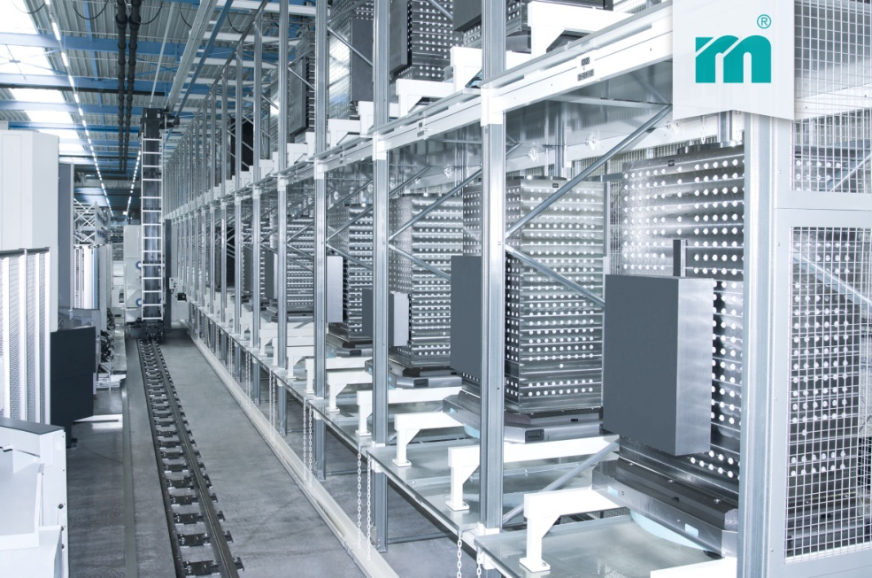

Caption: The word's largest standard parts warehouse

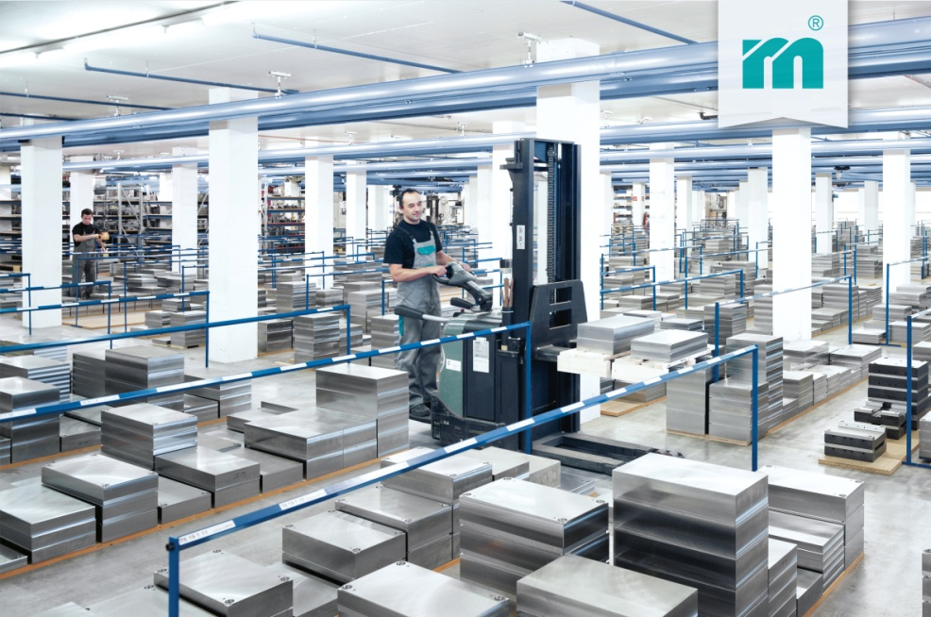

Caption: Hydraulic milling fixture for the automotive industry – machined with Meusburger standard components

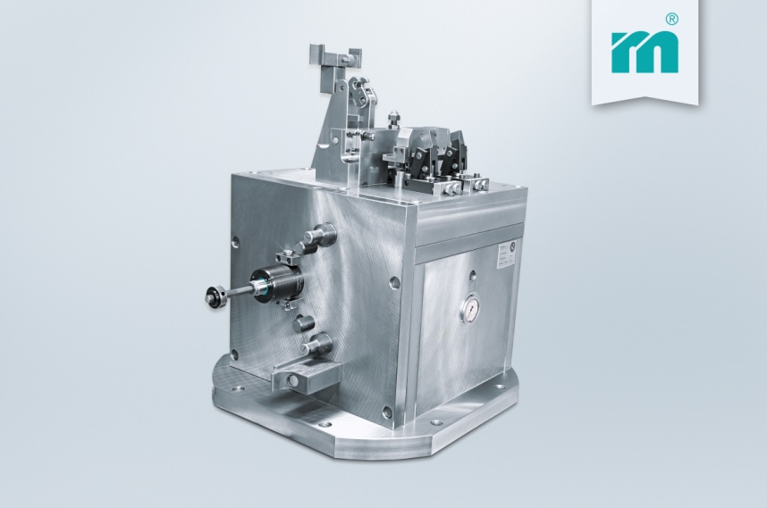

Caption: One of the three Meusburger furnaces

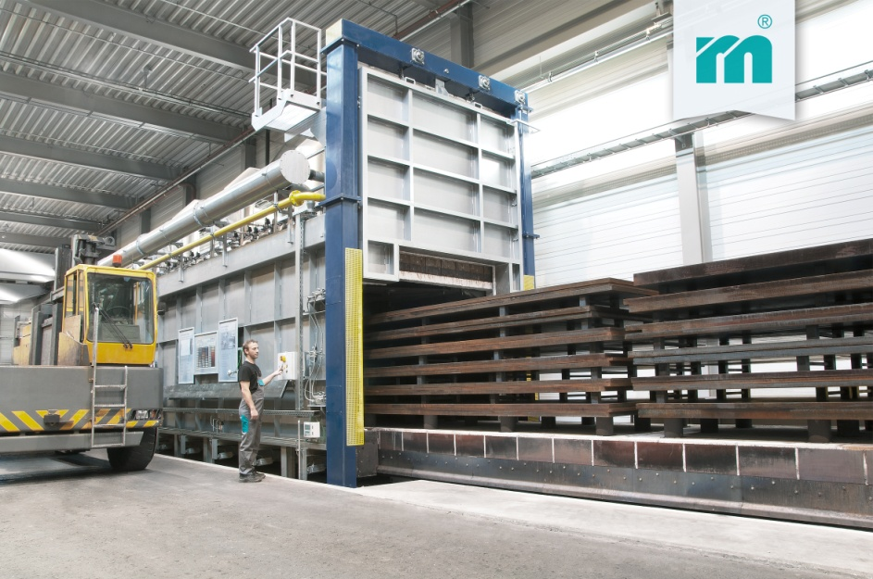

Setting Standards
Meusburger is the leading manufacturer in the field of high-precision standard parts. More than 17,000 customers all over the world make use of the numerous advantages of standardisation and benefit from the company's over 50 years of experience in working with steel. Offering an extensive range of standard parts, combined with high-grade products in the field of workshop equipment, Meusburger is the reliable global partner for making dies, moulds, jigs and fixtures.

Further information:
Meusburger Georg GmbH & Co KG
Communication / Public relations
Phone: + 43 5574 6706-0
Email address: presse@meusburger.com
www.meusburger.com/presse

