Press Release
Wolfurt, on 27.06.2019

Standardised stamping and forming die sets for Bihler presses

A brand-new market innovation is now available from Austrian standard parts manufacturer Meusburger and German stamping and forming machine specialist Bihler. In a close cooperation between the two companies, the first standardised stamping and forming die sets were developed with Meusburger standard parts for Bihler NC presses. The new die sets in types ‘tunnel cut’ or ‘spring-loaded guiding plate’ are available for stamping presses with forces up to 400kN and promise to bring enormous savings in time and cost for Meusburger and Bihler customers in future.

The German family company Bihler is the world’s leading system supplier for stamping and forming, welding and assembly technology. The leading standard parts manufacturer Meusburger has been working together with Bihler for many years. Thanks to their shared customer needs, the idea of creating a standard for stamping and forming die sets came about. The goal was to save customers costly and time-intensive individual production through the standardisation of die sets.

From small batches to large quantities
The newly developed SB stamping and forming die sets are available for Bihler NC presses with stamping forces of 200kN, 300kN and 400kN. The die sets are available in lengths up to 596 mm and as type ‘SBH tunnel cut’ or ‘SBP spring-loaded guiding plate’. While the tunnel cut version is primarily used for prototypes and small batches, the version with spring-loaded guiding plate is ideally suited for producing high precision parts and large quantities.

Benefits for customers
The standardisation of stamping and forming die sets has great advantages: they are significantly more cost-effective, and they are available from stock. The die sets themselves also offer many product advantages – from precision alignment edges to practical anti-rotation protection, as well as helpful mounting threads in the plates for pull handles, eye bolts and spacer discs, and useful vent holes.

Convenient wizard for stamping and forming die sets
For fast and easy design Meusburger has a digital wizard available in the web shop or as an offline version. In just a few clicks customers have a finished die set, are supported in the selection of the right components and can directly download the CAD data.

An efficient complete package
The technical development and realisation of the Meusburger stamping and forming die sets was carried out according to fixed parameters from Bihler to ensure perfect installation on the NC presses. Stamped and formed part manufacturers who already own a Bihler NC press can obtain the exclusive stamping and forming die sets quickly and easily from Meusburger. Those considering the purchase of a new Bihler Servo stamping and forming machine type RM-NC or GRM-NC with die set will receive an offer from Bihler for the entire package, made up of the NC stamping and forming machine including the suitable standard stamping and forming die set from Meusburger. All in all, a successful cooperation with a perfectly rounded out complete package for the customer.

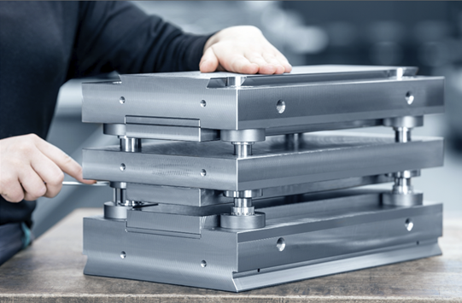
Image source: Meusburger, publication free of charge
File name: Bihler-Meusburger-Team
Caption: The SBP Stamping and forming die set with spring-loaded guiding plate from Meusburger

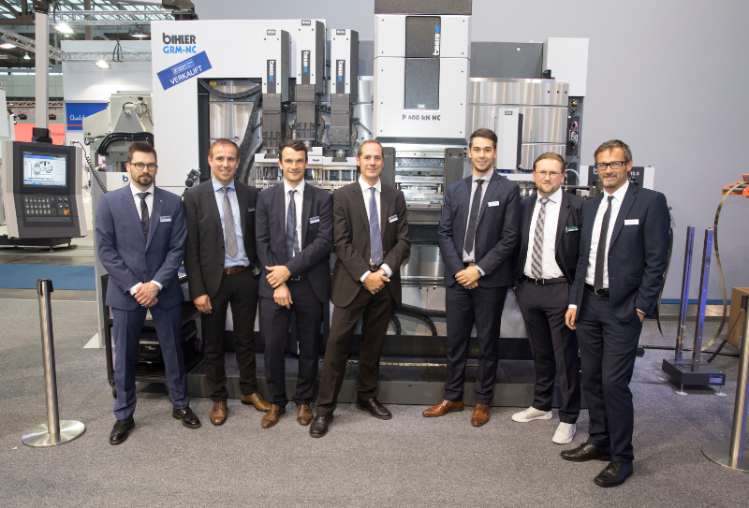
Image source: Bihler, publication free of charge
File name: Bihler-Meusburger-Team
Caption: The project team from Meusburger and Bihler, from left to right: Thomas Zettlmeier, Gerhard Krammel
Marc Walter, Christoph Schäfer, Andreas Gojo, Simon Kott und Thomas Enz

Meusburger – Setting Standards.

As a part of the Meusburger Group, the Meusburger company is the market leader in the field of high-precision standard parts. 21,000 customers all over the world make use of the advantages of standardisation and benefit from the company's over 50 years of experience in working with steel. Offering an extensive range of standard parts, combined with selected products in the field of workshop equipment, Meusburger is the reliable global partner for making moulds, dies, jigs and fixtures.

Press contact

Meusburger Georg GmbH & Co KG
Communication / Public relations
Phone: +43 5574 6706-0
Email: press@meusburger.com
www.meusburger.com

