Press Release
Wolfurt, on 29.10.2019

Market innovations presented by Meusburger at the K trade fair

At this year’s K trade fair in Düsseldorf, the Meusburger stand featured the new configurator for hot runner moulds. The new cavity pressure sensors and many other Meusburger products were also presented to visitors, alongside the unmissable hot runner and control systems, WBI Knowledge Management and ERP software.

At this year’s K in Düsseldorf, the leading trade fair for the plastic industry, everything at the popular Meusburger stand revolved around the new configurator for hot runner moulds, which is available exclusively at Meusburger. The complete mould base including hot runner manifold can be customised with just a few clicks and shipped shortly thereafter in the usual high quality in just one order. In addition to the hot runner mould, the required components and matching accessories can be ordered directly from Meusburger. During the K, the many visitors to the Meusburger stand learned about the benefits of the new configurator.

New sensors for more process reliability
As their second product highlight, Meusburger presented their new cavity pressure sensors. The sensors are immediately available from stock, and represent a further step towards industry 4.0. They offer maximum flexibility through direct or indirect cavity pressure measurement and are compatible with all common piezoelectric pressure sensors. Another benefit: the small installation spaces ensure a high degree of freedom in the mould design.

Everything from a single source
The PSG branded product range for hot runner and control systems also offered a lot for visitors. While in the field of hot runners the focus is on customised solutions, in the field of control systems when it comes to reduced cycle times, rapid colour changes, and gating of difficult to reach parts the profiTEMP+ hot runner controller impresses with state-of-the-art technology and space saving design.

Digitalisation has arrived
As a digital addition to the range, WBI Knowledge Management presented their software specially developed for the Knowledge Management Method at the Meusburger stand. With the help of this software, the resource of knowledge can be collected, shared, further developed and saved. At the same time, the ERP software SEGONI.PPMS was presented to visitors, which is used for efficient production planning and focuses on companies with individual production structures active in the fields of mould, die, and jigs and fixtures construction. Thanks to these digital tools, Meusburger helps their customers to achieve sustainable success along the entire value chain.

Further information: www.meusburger.com

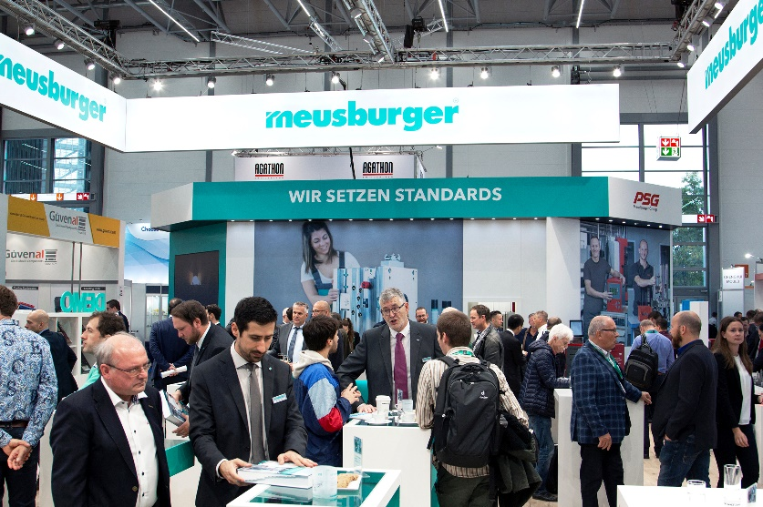
Image source: Meusburger publication free of charge
Caption: Meusburger presents tried and trusted as well as new products at the K 2019.
Press contact

Meusburger Georg GmbH & Co KG
Communication / Public relations
Phone: +43 5574 6706-0
Email: press@meusburger.com
www.meusburger.com
Meusburger – Setting Standards.

Meusburger is the market leader in the field of high-precision standard parts. 21,000 customers all over the world make use of the advantages of standardisation and benefit from the company's over 50 years of experience in working with steel. Offering an extensive range of standard parts, combined with selected products in the field of workshop equipment, Meusburger is the reliable global partner for making moulds, dies, jigs and fixtures.

