Meusburger Georg GmbH & Co KG
Kesselstr. 42, 6960 Wolfurt, Austria

High-quality steel for metalworking
- Meusburger shows the advantages of standardisation at METAV 2018

From 20-24 February the 20th International Exhibition for Metalworking Technologies will be held in Düsseldorf. Meusburger will also be represented this year in Hall 15 at Stand 15F69 and informing visitors about the competitive advantages of standardisation in machine and jig construction.

Competitive advantages with heat treated for stress relief semi-finished products
The trend towards standardisation is increasingly taking hold in machine and jig construction. A logical development, considering that with progressing globalisation, ever shorter project lead times and efficiency improvements are required in order to survive on the international market.
To match this demand Meusburger offers a comprehensive range of semi-finished products – from heat treated for stress relief plates and bars from stock to special plates. The precisely prefabricated plates and bars can be delivered to Germany, Austria and Switzerland within 24 hours. In addition, all products for machine and jig construction are available in different material grades and variations.

Manufacturing technologies at Meusburger
Meusburger offers a variety of manufacturing technologies like flame cutting, sawing, deep hole drilling, milling, grinding and turning. The web shop enables quick and easy calculation and design. Through the prefabricated flame-cuts and milling service, customers can save their resources and concentrate on their own core competences. At METAV, visitors have the opportunity to have a close look at samples from the different manufacturing technologies.

Expansion of the standard and round bars range at Meusburger
Since the end of 2017, standard bars in lengths of 300 and 1,200 mm have been a part of the standard parts manufacturer’s range. These are now ready for dispatch in the 18,000 m² finished goods warehouse. At Meusburger all bars and plates are heat treated for stress relief, thus reduced plate warping during machining is guaranteed.

We are looking forward to your visit at METAV: in Hall 15 at Stand 15F69

Picture credits: Photo (Meusburger)
Caption: The daily capacity of the Meusburger furnaces is 240 tonnes

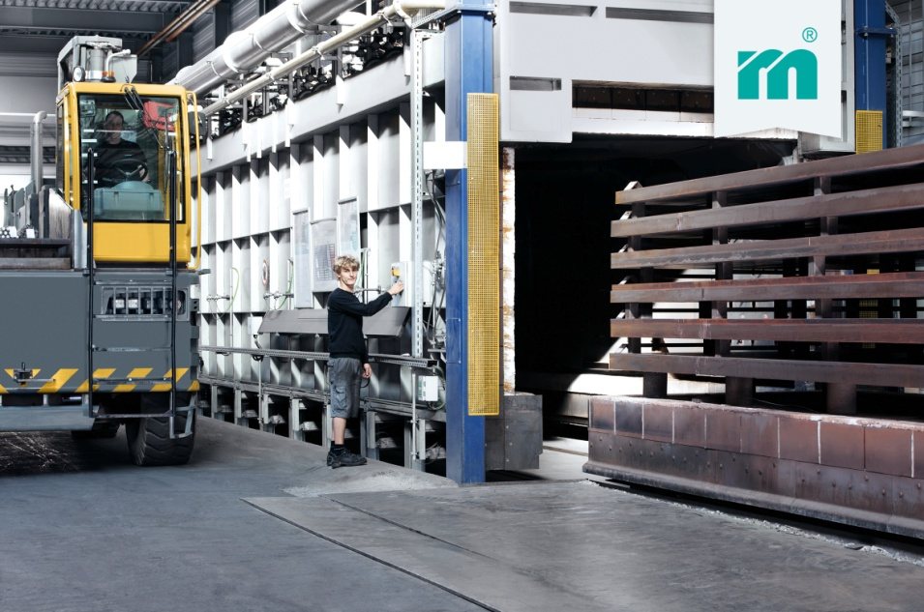

Meusburger – Setting Standards
The Meusburger Group is the leading international manufacturer of high-quality standard parts, hot runner and control systems and selected items in workshop equipment. More than 17,500 customers all over the world make use of the numerous advantages of standardisation and benefit from the company's over 50 years of experience in working with steel. The permanent availability of products makes the Meusburger Group the reliable and global partner for die, mould, and jigs and fixtures construction.

Further information:
Meusburger Georg GmbH & Co KG
Communication / Public relations
Lia Klimmer
Phone: + 43 5574 6706-1446
Email: press@meusburger.compresse@meusburger.com
http://www.meusburger.com/en/press/press.html

