Meusburger Georg GmbH & Co KG
Kesselstr. 42, 6960 Wolfurt, Austria

The Meusburger highlights at the Fakuma 2017

From the 17th to the 21st of October, Meusburger presents both the tried and trusted products and numerous innovations at the international trade fair for the processing of plastics. The precision cutting and grinding machine, the gear unit for stack moulds, and the high temperature hose are just a few of the product highlights that can be seen at the Meusburger stand no. 2313 in hall A2.

Try out the innovations directly
Mould makers can see the many innovations directly for themselves at the Meusburger trade fair stand. The E 8630 Gear unit for stack moulds can also be tested in installed form. This item convinces by the ground and induction hardened gear wheels and gear racks in module 3 and 4. In addition the newly developed E 2187 Isotemp® is exhibited at the trade fair. The high temperature hose ensures more safety during the injection moulding process through the new silicone sheath. In addition to these and other highlights, the GMT 6000 Precision cutting and grinding machine will be presented for the first time and put into operation live directly on site.

New standard bar length at Meusburger
Also new in the range of the standard parts manufacturer are the standard bars in the lengths 300 and 1,200 mm. These are now ready for dispatch in the 18,000 m² finished goods warehouse. At Meusburger the bars and plates are heat treated for stress relief thus reduced plate warping during machining is guaranteed.

Tried and trusted Meusburger classics
In addition to the innovations, the tried and trusted products will again be presented at the Meusburger trade fair stand. The multifunctional H 1000 Clamping system has revolutionised the manufacturing processes in mould making and stands for high efficiency. The system enables precise clamping of the plates with repeatable accuracy in the µ range. The innovative H 4062 Assembly table facilitates repair and assembly work on moulds. By way of multiple air nozzles, an air cushion is created on the underside of the moveable plate supports. This enables light and easy movement of the tool halves. Both split line faces are freely accessible without having to reposition or turn them around, enabling efficient operating.

A look behind the scenes of the expert in standard components
Take the opportunity to visit Meusburger at its headquarters in Vorarlberg. Due to the proximity to the trade fair, the expert in standard components offers a daily company tour during the Fakuma. Registration for the exciting glimpse behind the scenes is possible until the end of September at m.koch@meusburger.com.

Picture credits: Photo (Meusburger)
Caption: The Meusburger stand is always worth a visit

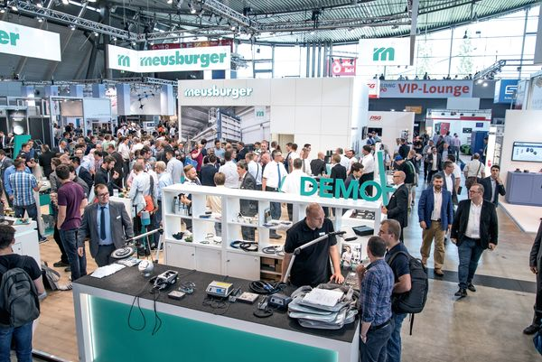

Picture credits: Photo (Meusburger)
Caption: Interesting technical discussions in a relaxed environment

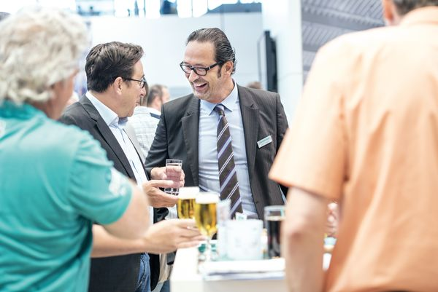

Meusburger Group – Setting Standards

The Meusburger Group is the leading international manufacturer of high-quality standard parts, hot runner and control systems and selected items in workshop equipment. More than 17,500 customers all over the world make use of the numerous advantages of standardisation and benefit from the company's over 50 years of experience in working with steel. The permanent availability of products makes the Meusburger Group the reliable and global partner for die, mould, jigs and fixtures construction.

Further information:
Meusburger Georg GmbH & Co KG
Communication / Public relations
Lia Klimmer
Phone: + 43 5574 6706-1446
Email: presse@meusburger.compresse@meusburger.com
http://www.meusburger.com/press-releases

