Meusburger Georg GmbH & Co KG
Kesselstr. 42, 6960 Wolfurt, Austria

Achieve maximum precision with the Meusburger guide pillar with centre collar

Especially developed for the modular concept, the E 5076 Guide pillar with centre collar allows for a high number of strokes through best surface quality. In addition it offers maximum stiffness through fixing in the guiding plate and highest precision with tolerance class of h3.

The standard parts manufacturer Meusburger expands its range of practical standard parts for easy installation and optimal guiding of die modules. Decisive advantages of using modules are the quicker tool changes resulting in reduced downtimes. The new Meusburger E 5076 Guide pillar with centre collar was especially developed for the modular concept and is available in diameters of 12 to 19 mm. By Superfinishing a high surface quality of Ra 0.1 is reached. This enables a high number of strokes and very low vibration. The guide pillar can be pressed into the guiding plate or fixed by means of retainer clips. This ensures maximum stiffness as well as optimal space utilization within the stamping die. Therefore the user is often spared from using the next larger size of module. For an efficient installation and/or removal of the guide pillar the expert in standard components offers the eccentric E 5270 Retainer clip. The CAD data for the pillars are available for download in the Meusburger portal with just a few clicks. The new guide pillar and further innovative products related to the modular concept are, as is usual with Meusburger, available from stock.

Picture credits: Photo (Meusburger)
Caption: Highest precision due to Meusburger guide pillar with centre collar

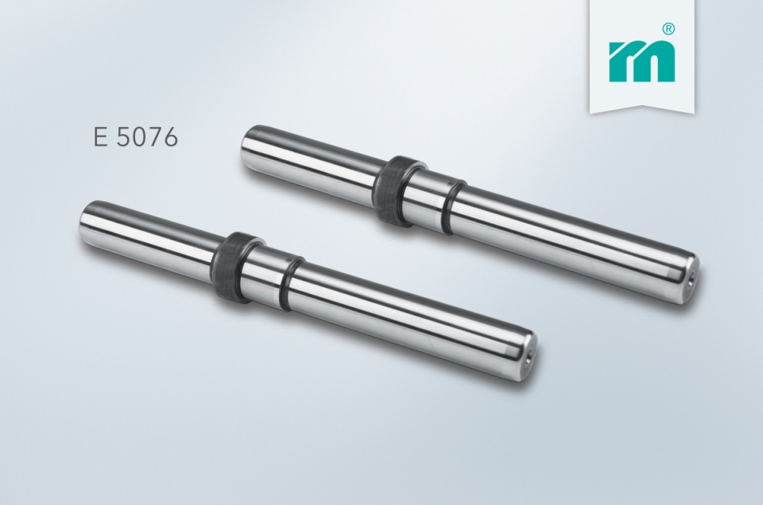

Meusburger – Setting Standards
Meusburger is the leading manufacturer of high-precision standard parts. More than 17,000 customers all over the world make use of the numerous advantages of standardisation and benefit from the company's over 50 years of experience in working with steel. Offering an extensive range of standard parts, combined with high-grade products in the field of workshop equipment, Meusburger is the reliable global partner for making dies, moulds, jigs and fixtures.

Further information:
Meusburger Georg GmbH & Co KG
Lia Klimmer
Communication / Public relations
Phone: + 43 5574 6706-1446
Email: press@meusburger.compresse@meusburger.com
www.meusburger.com/press-releases

