Meusburger Georg GmbH & Co KG
Kesselstr. 42, 6960 Wolfurt, Austria

NEW from Meusburger – In-house manufactured cutting punches with round base

The standard parts manufacturer responds to customer requests and now offers a wide range of cutting punches with round bases. These are manufactured in-house within a short time span with the new automated cylindrical grinding machine. Therefore Meusburger can guarantee especially attractive lead times. The cutting punches with round bases are available in the standard range as well as in configurable versions in different head shapes and materials. For the configurable punches the cutting edge length is freely selectable and the cutting edge diameter in steps of one-hundredth. With the cutting punch configurator from Meusburger the suitable part can be configured in just a few clicks in the online shop. CAD data is immediately available for download. All new products from Meusburger are in the usual high quality and available from stock.

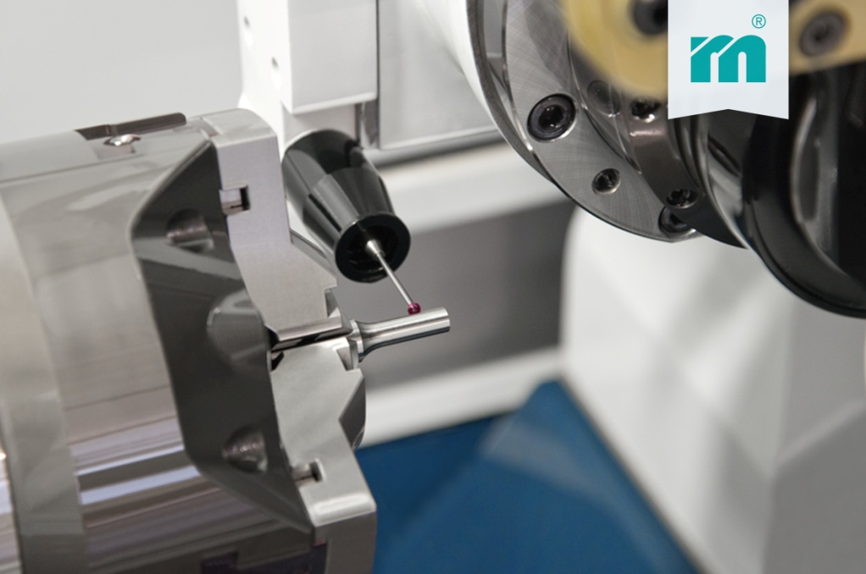

Picture credits: Photo (Meusburger)
Captions: NEW from Meusburger – In-house manufactured cutting punches with round bases

Meusburger – Setting Standards.
Meusburger is the leading manufacturer in the field of high-precision standard parts. More than 17,000 customers all over the world make use of the numerous advantages of standardisation and benefit from the company's over 50 years of experience in working with steel. Offering an extensive range of standard parts, combined with high-grade products in the field of workshop equipment, Meusburger is the reliable global partner for making dies, moulds, jigs and fixtures.

Further information:
Meusburger Georg GmbH & Co KG
Communication / Public relations
Phone: 0043 (0) 5574 6706-0
Email: presse@meusburger.com
http://www.meusburger.com/press/press.html

