Meusburger Georg GmbH & Co KG
Kesselstr. 42, 6960 Wolfurt, Austria

Tried and trusted latch locks – now with DLC coating

As of now, the switching elements of the Meusburger E 1820 Flat latch lock and E 1840 Round latch lock are DLC coated. This enables an even longer service life and, due to excellent dry-running properties, makes the latch locks suitable for use in cleanrooms.

The high-quality latch locks are used for controlling and secure locking of the floating plate in 3-plate moulds. The compact E 1820 Flat latch lock ensures optimal force transmission through its stable, large surface latches. With their DLC coated switching elements, the Meusburger flat latch locks have an even longer service life. Their precise control cams ensure accurate switching while the integrated damper provides for smooth and quiet operation.
The Meusburger E 1840 Round latch lock is the optimal solution for mould bases where no protruding attachments are allowed. The installation space required for the round latch lock can be easily created through unidirectional machining. Because of the DLC coated switching elements and catch part, the round latch lock can now also be used in cleanrooms. In addition, the coating reduces the wear. Selection of the Meusburger latch locks in the online shop is quite simple and can be done with just a few mouse clicks: all the customer has to do is enter the required parameters, then export the ready-to-use latch locks to his CAD software. As is usual with Meusburger, both products are immediately available from stock.

Picture credits: Photo (Meusburger)
Caption: Tried and trusted latch locks – now with DLC coating

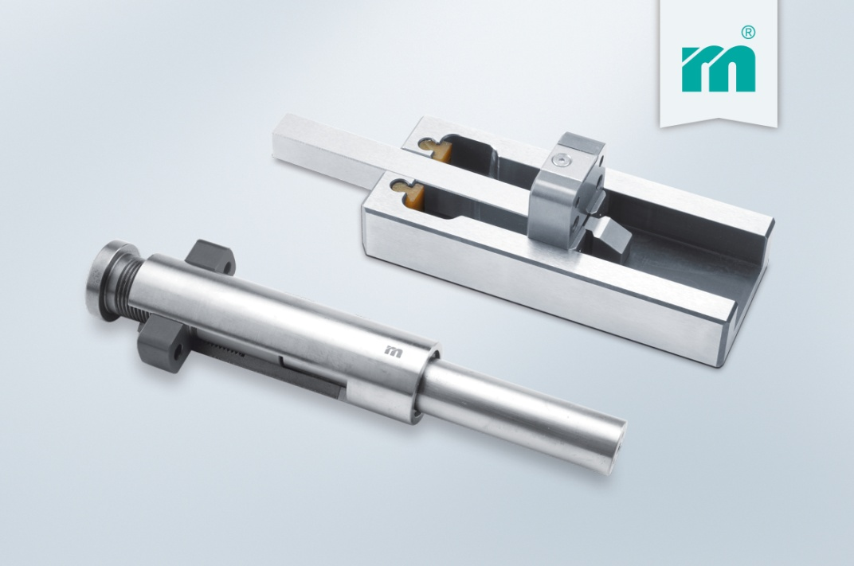

Meusburger – Setting Standards
Meusburger is the leading manufacturer of high-precision standard parts. More than 17,000 customers all over the world make use of the numerous advantages of standardisation and benefit from the company's over 50 years of experience in working with steel. Offering an extensive range of standard parts, combined with high-grade products in the field of workshop equipment, Meusburger is the reliable global partner for making dies, moulds, jigs and fixtures.

Further information:
Meusburger Georg GmbH & Co KG
Communication / Public relations
Phone: + 43 5574 6706-0
Email: press@meusburger.compresse@meusburger.com
www.meusburger.com/press-releases

