Meusburger Georg GmbH & Co KG
Kesselstr. 42, 6960 Wolfurt, Austria

Meusburger expands its range in the area of gas springs

Meusburger now offers additional gas springs with high initial forces and compact designs. With the corresponding selection guide you can find the appropriate gas spring for your application with just a few clicks. The CAD data is also available for download online.
The standard parts manufacturer Meusburger offers the ‘E 6350 Gas spring – Force’ with three different initial forces per stroke. The E 6350 is characterised by high initial forces and compact design. The gas springs are provided with coloured rings so that the initial force is easily identified. In addition, the active safety systems protect against overstroke (Over Stroke Active Safety), uncontrolled return (Uncontrolled Speed Active Safety), and overpressure (Over Pressure Active Safety). The ‘Gas spring – Force’ is available with a large selection of initial forces in small steps for every application. Furthermore the gas springs are designed and manufactured according to the PED directive (Pressure Equipment Directive) 97/23/EC with modern computer-assisted methods. Find the appropriate gas spring quickly and easily with the selection guide available in the Meusburger web shop and CD catalogue.

Picture credits: Photo (Meusburger)
Caption: Meusburger expands its range in the area of gas springs

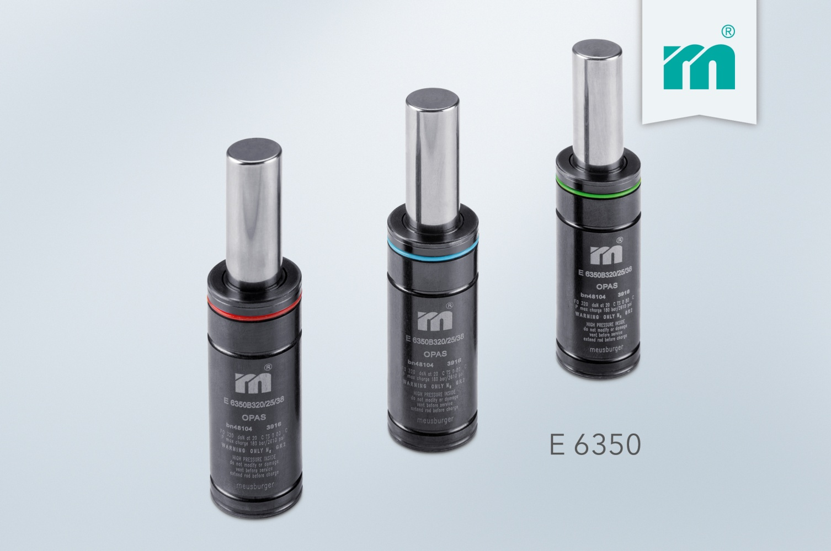

Meusburger Group – Setting Standards

The Meusburger Group is the leading international manufacturer of high-quality standard parts, hot runner and control systems and selected items in workshop equipment. More than 17,500 customers all over the world make use of the numerous advantages of standardisation and benefit from the company's over 50 years of experience in working with steel. The permanent availability of products makes the Meusburger Group the reliable and global partner for die, mould, jigs and fixtures construction.

Further information:
Meusburger Georg GmbH & Co KG
Communication / Public relations
Lia Klimmer
Phone: + 43 5574 6706-1446
Email: presse@meusburger.compresse@meusburger.com
http://www.meusburger.com/en/press/press.html

