Meusburger Georg GmbH & Co KG
Kesselstr. 42, 6960 Wolfurt, Austria

Meusburger expands its range in the area of active parts

The standard parts manufacturer Meusburger now offers three new, innovative components in the area of active parts: a punch suspension piece with radius for fixing and installation of filigree punches, a block-shaped strip lifter with large contact surface and an additional size for the tried and trusted infeed guide for strip widths up to 152 mm.

The E 5665 Punch suspension piece with radius offers optimal fixing and installation of filigree punches. The standardised solution saves you the laborious cutting of fixing threads in the punch. The free-of-play installation of the punch suspension piece enables a floating mounting of the stamp. This product is available in 4 different sizes.

Exclusively in the range of the standard parts manufacturer Meusburger is the E 5644 Block-shaped strip lifter which guarantees a reliable lifting and forward pushing of the metal strip through the large contact surface. The integrated initial bore with a diameter of 1 mm allows for making a clearance hole for pilot pins. Furthermore, the functional dimensions were optimally coordinated to the plate thickness.

The modularly designed E 5620 and E 5622 Infeed guides are now available in an additional size. Therefore strip widths up to 152 mm can be inserted in the stamping die. The reference holes in the base plate are also new. With these, the strip width can be adjusted simply and exactly by means of the gauge block before the assembly on the stamping die.

As always with Meusburger, all three expansions are available from stock. The CAD data is available in the web shop with just a few clicks.

Picture credits: Photo (Meusburger)
Caption: Meusburger expands its range in the area of active parts

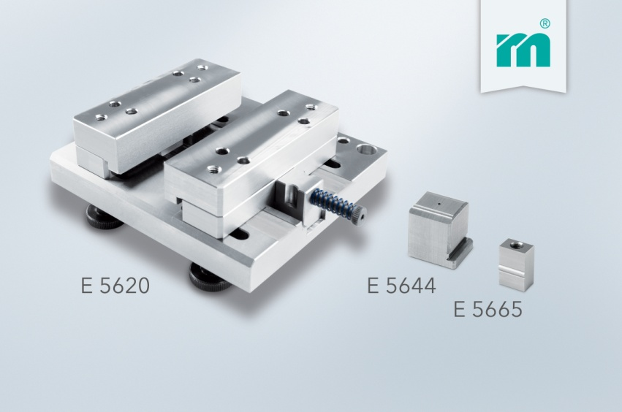

Meusburger – Setting Standards
Meusburger is the leading manufacturer of high-precision standard parts. More than 17,000 customers all over the world make use of the numerous advantages of standardisation and benefit from the company's over 50 years of experience in working with steel. Offering an extensive range of standard parts, combined with high-grade products in the field of workshop equipment, Meusburger is the reliable global partner for making dies, moulds, jigs and fixtures.

Further information:
Meusburger Georg GmbH & Co KG
Communication / Public relations
Lia Klimmer
Phone: + 43 5574 6706-1446
Email: presse@meusburger.compresse@meusburger.com
www.meusburger.com/press-releases

