Meusburger Georg GmbH & Co KG
Kesselstr. 42, 6960 Wolfurt, Austria

Proper heat treatment paves the way to success

Not all stress-relieving heat treatment is the same – because only a proper heat treatment process ensures the desired result in the end. That is why Meusburger has been using its own furnaces for almost 30 years. Meusburger stands for top-quality products – only flawless steel from the best-known steelworks can make it through the quality check. Standard parts that are heat-treated for stress relief are right at the beginning of the die and mould making process chain and form the basis of high-quality moulds and dies.

The heat treatment strength lies in rest
In order to reduce tension in the material to a minimum, in addition to the controlled heating of the sheet metal and the maintaining of the temperature at approximately 580°C, it is especially the uniform cooling that is decisive. At Meusburger the entire heating process, which lasts about 24 hours, takes place in a closed furnace. It is only when stress-relieving heat treatment is carried out correctly that temperature fluctuations and thus the build-up of new tension in the material is prevented, while both the microstructure and the mechanical strength of the material remain unchanged.

Less wear, more capacity
The procedure, from the precise inspection of the sheet metal through to the perfectly executed stress-relieving heat treatment, guarantees low-deformation processing of Meusburger products. The tension in the material is reduced to a minimum. This reduces the load on machines and tools, ensures improved surface quality and lowers the risk of tool breakage. The low warping also ensures that less reworking is necessary, and reduces wear on the cutting tools. The resulting reduced machining time and longer service life allow for free capacity for other tasks.

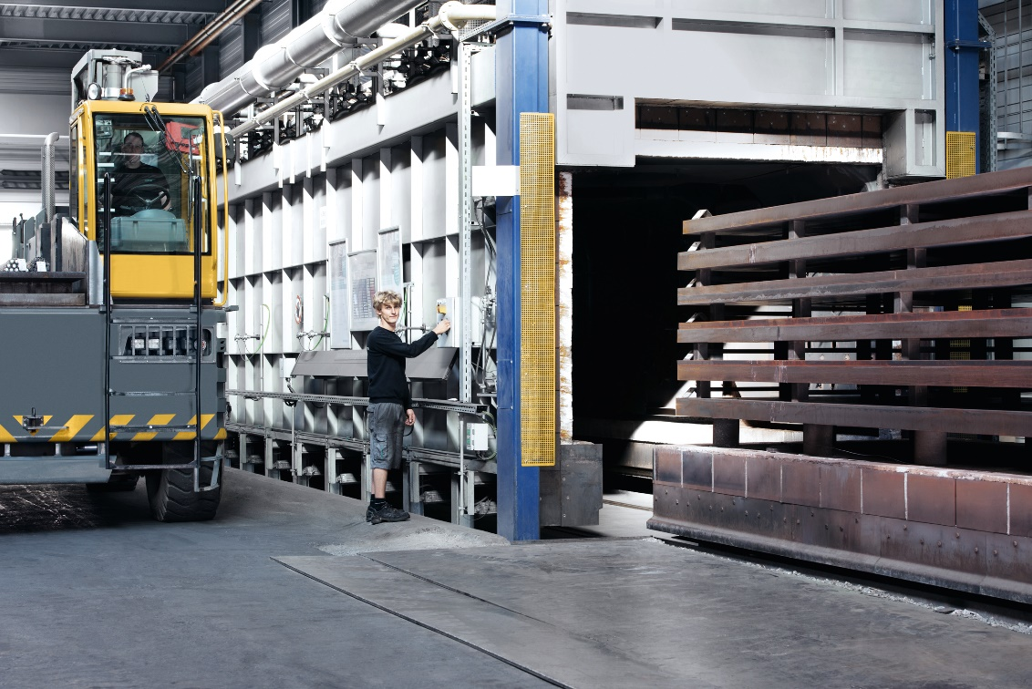
Picture credits: Photo (Meusburger)
Caption: Meusburger has three furnaces with a total daily capacity of 240 tonnes of steel
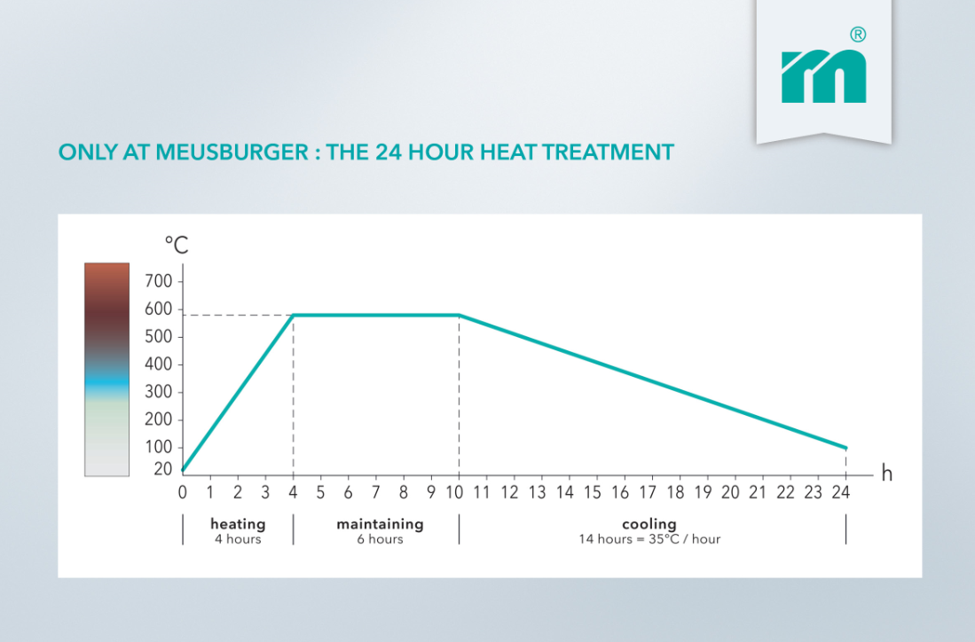
Picture credits: Photo (Meusburger)
Caption: Through the stress-relieving heat treatment, the tension in the material is minimised without major changes to the microstructure or strength.

Meusburger – Setting Standards

As a part of the Meusburger Group, the Meusburger company is the market leader in the field of high-precision standard parts. Customers all over the world make use of the advantages of standardisation and benefit from the company's over 50 years of experience in working with steel. Offering an extensive range of standard parts, combined with selected products in the field of workshop equipment, Meusburger is the reliable global partner for making moulds, dies, jigs and fixtures.

Further information:
Meusburger Georg GmbH & Co KG
Communication / Public relations
Phone: + 43 5574 6706-0
Email: press@meusburger.compresse@meusburger.com
http://www.meusburger.com

