PRESS RELEASE
Wolfurt, 19.02.2019

New embossing elements for die making

With the new embossing elements from Meusburger, stamped parts can be marked quickly and easily. On the one hand this serves for clear traceability of stamped parts, and on the other hand for visual monitoring of the correct machine parameters.
The E 5674 Embossing stamp holder with the matching E 56742 Inserts ensure flexible marking of stamped parts with four or six digits. This allows different combinations for batch or date controls. In addition, the embossing stamp holder fulfils the criteria of the PSA standard.

With the E 5676 Visual locator setting punch, visual monitoring can be carried out at the BDC position of the die. The serrated ring of the visual locator setting punch is pressed into the punching strip when the stamping die is closed in order to visually represent the correct position of the die. The visual locator setting punch is available from stock in diameters 10 and 13 mm.

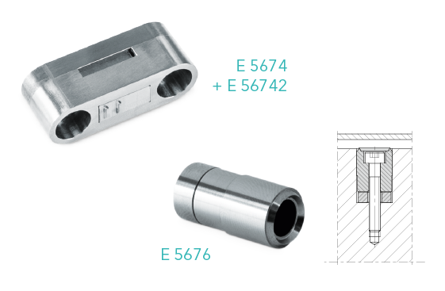
Picture credits: Meusburger, Veröffentlichung honorarfrei
Caption: New embossing elements for die making

Meusburger – Setting Standards.

As a part of the Meusburger Group, the Meusburger company is the market leader in the field of high-precision standard parts. Customers all over the world make use of the advantages of standardisation and benefit from the company's over 50 years of experience in working with steel. Offering an extensive range of standard parts, combined with selected products in the field of workshop equipment, Meusburger is the reliable global partner for making moulds, dies, jigs and fixtures.

Further information

Meusburger Georg GmbH & Co KG
Communication / Public relations
Phone: +43 5574 6706-0
Email: press@meusburger.com
www.meusburger.com

