Meusburger Georg GmbH & Co KG
Kesselstr. 42, 6960 Wolfurt, Austria

NEW from Meusburger: Blocks for eroding with starting hole

For wire EDM, a starting hole in the block for eroding is advantageous since otherwise the EDM contour cannot be optimally determined and it leads to high wear if the wire is introduced from the side. That’s why Meusburger now provides the new NE-Blocks for eroding with customisable starting holes.

At Meusburger, the position of all starting holes – with Ø of 1 mm – is freely configurable. Up to 10 starting holes can be defined, depending on the subsequent EDM contour. This guarantees maximum flexibility in the design. The selection is done in just a few steps in the Meusburger web shop or offline shop. First the suitable block for eroding is selected. This is available in 7 different materials, in heat treated or hardened versions, as well as in many different sizes. Then a window automatically opens, asking if starting holes should be defined. If this is confirmed with a YES, the X and Y coordinates for the respective starting holes can be entered quickly and easily.
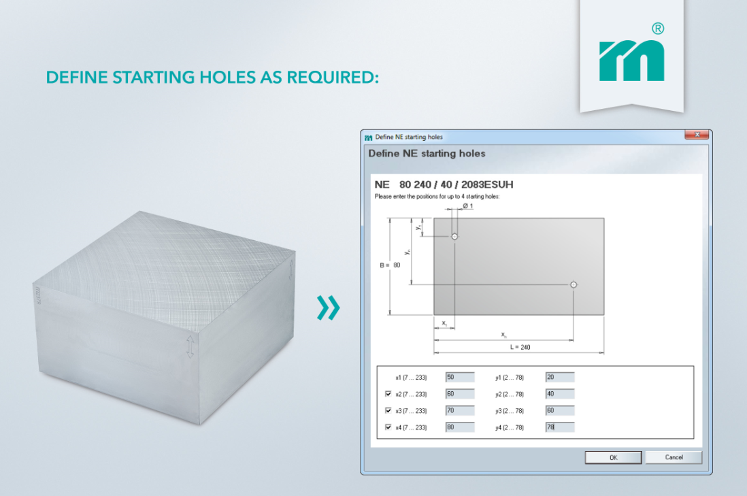
Picture credits: Photo (Meusburger)
Caption: Configured with just a few steps in the Meusburger web shop or offline shop: blocks for eroding with customisable starting holes.

Meusburger – Setting Standards

As a part of the Meusburger Group, the Meusburger company is the market leader in the field of high-precision standard parts. Customers all over the world make use of the advantages of standardisation and benefit from the company's over 50 years of experience in working with steel. Offering an extensive range of standard parts, combined with selected products in the field of workshop equipment, Meusburger is the reliable global partner for making moulds, dies, jigs and fixtures.

Further information:
Meusburger Georg GmbH & Co KG
Communication / Public relations
Phone: + 43 5574 6706-0
Email: press@meusburger.compresse@meusburger.com
http://www.meusburger.com/en/press/press.html

