Meusburger Georg GmbH & Co KG
Kesselstr. 42, 6960 Wolfurt, Austria

Meusburger launches new consumables for the food processing industry

The standard parts manufacturer Meusburger offers selected consumables with H1-food-safe approval. The high-quality products are therefore especially suitable for the food processing industry. In this sector all substances such as grease, oil, compounds or anticorrosives are subject to high standards so they must be selected with particular care. New in the Meusburger range are for example the VGI 250 S Lubricant and release agent and the VPG 70 FD Food-safe anti-corrosive.

VGI 260 and VGI 300 Fully synthetic inert grease
The Meusburger fully synthetic inert grease is usable at very high temperatures of 260°C and 300°C. VGI 260 with PTFE can be used for lubricating any sliding pairs in die and mould making that are subject to high shear forces. The fully synthetic inert grease VGI 300 is ideal for lubricating ejectors and for applications requiring tight tolerances and very long relubrication intervals.

VGS 160 FD High-performance food-safe grease
Just like the inert grease, the Meusburger high-performance grease VGS 160 FD, which is usable at temperatures of up to 160°C, is perfect for the food processing industry. The versatile grease is ideally suited for lubricating ejectors, pillars, sliders and all other movable and sliding components embedded in injection moulds and die sets.

VGI 250 S Lubricant and release agent
The Meusburger VGI 250 S can be used both as a lubricant and a release agent. It is ideal for applications in the food processing industry, for example for easy relubrication after use of PFPE lubricants. As a release agent this consumable is especially designed for the processing of plastics.

VAP 1000 White assembly paste
In the lubricants category, the expert in standard components also offers an assembly paste with H1 food-safe approval. This can be used for example for mounting highly stressed screw and plug connections and for lubricating extremely stressed gliding points. It also helps loosening tight screws and sprues on injection moulding machines, even after long machine downtimes or idle states. In addition, the white assembly paste from Meusburger protects against corrosion, erosion, unwanted cold-shut and frictional corrosion.

VPG 70 FD Food-safe anti-corrosive
Among the Meusburger range of anti-corrosion agents, the VPG 70 FD anti-corrosive is the ideal product for preserving cavities in injection moulds and other metallic surfaces in the food processing industry.

Picture credits: Photo (Meusburger)
Caption: Meusburger launches new consumables for the food processing industry

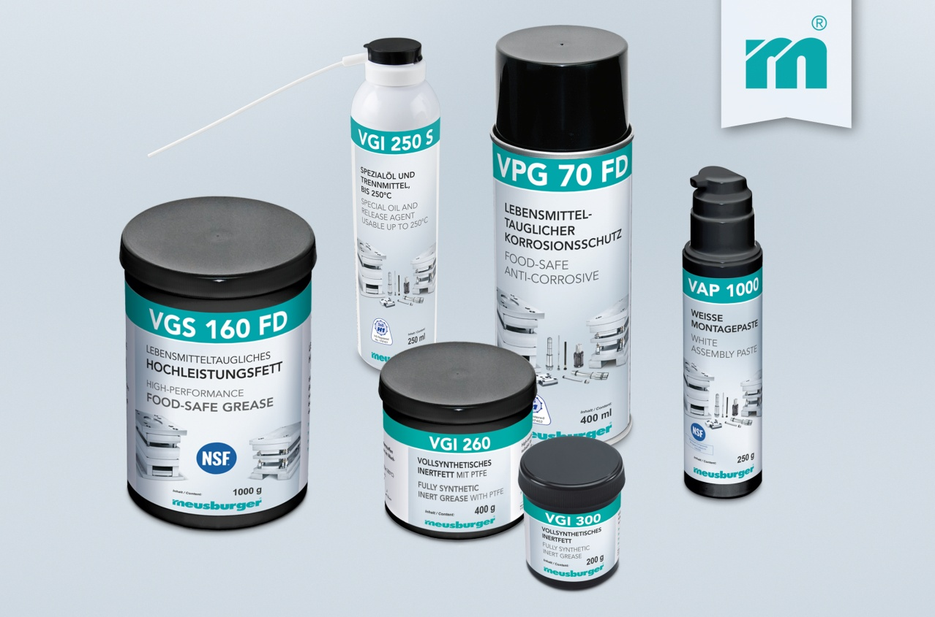

Meusburger – Setting Standards
Meusburger is the leading manufacturer of high-precision standard parts. More than 17,000 customers all over the world make use of the numerous advantages of standardisation and benefit from the company's over 50 years of experience in working with steel. Offering an extensive range of standard parts, combined with high-grade products in the field of workshop equipment, Meusburger is the reliable global partner for making dies, moulds, jigs and fixtures.

Further information:
Meusburger Georg GmbH & Co KG
Communication / Public relations
Phone: 0043 (0) 5574 6706-0
Email: presse@meusburger.com
http://www.meusburger.com/press-releases

