Meusburger Georg GmbH & Co KG
Kesselstr. 42, 6960 Wolfurt, Austria

NEW from Meusburger – Automatic safety hose coupler for cooling circuit connections

An innovative solution in the area of temperature regulation components assures more safety at work.
Risk of scalding starts at a water temperature of 55°C, therefore an unintentional decoupling of the temperature regulation components can have fatal consequences. The new automatic safety hose coupler can prevent such accidents. Compared to the other commonly used systems in which the locking mechanism is manual and thus user-dependent, the locking mechanism here takes place automatically during the coupling. The optical marking indicates the locking state to the user and therefore provides a safe way of working. The decoupling is very easy and is performed through a simple and intuitive one-hand operation. Due to the unique sealing, the safety hose coupler is also suitable for applications at high temperatures. For continuous operation up to a maximum of 200°C under oil and up to a maximum of 160°C under water. The new safety hose coupler is available from stock at Meusburger with hose nozzle as well as with thread in straight 45° and 90° versions.

Picture credits: Photo (Meusburger)
Caption: NEW from Meusburger – Automatic safety hose coupler for cooling circuit connections

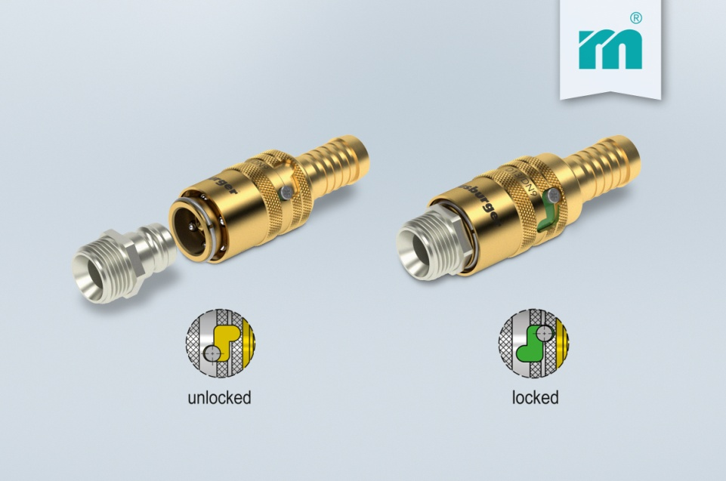

Meusburger – Setting Standards
Meusburger is the leading manufacturer of high-precision standard parts. More than 17,000 customers all over the world make use of the numerous advantages of standardisation and benefit from the company's over 50 years of experience in working with steel. Offering an extensive range of standard parts, combined with high-grade products in the field of workshop equipment, Meusburger is the reliable global partner for making dies, moulds, jigs and fixtures.

Further information:
Meusburger Georg GmbH & Co KG
Communication / Public relations
Phone: 0043 (0) 5574 6706-0
Email address: presse@meusburger.com
www.meusburger.com/press-releases

