Press Release
Wolfurt, on 26.03.2019

The Meusburger Group at Moulding Expo 2019

At this year’s Moulding Expo in Stuttgart (21–24 May), the Meusburger Group’s stand (hall 7, stand C17) will feature the brand new and one-of-a-kind configurator for hot runner moulds. In addition, the new cavity pressure sensors and many other Meusburger products will be presented. The companies PSG, WBI and Segoni will also offer a glimpse into their product range.

A special highlight at this year’s Moulding Expo is the brand new configurator for hot runner moulds, which is offered exclusively in cooperation between Meusburger and PSG. The complete mould base including hot runner manifold is customised with just a few clicks and dispatched shortly thereafter as just one order and in the usual high quality. In addition to the hot runner mould, the required components and the right accessories can also be ordered directly from Meusburger. This way the customer receives everything from just one source and with only one order.

New sensors for more flexibility
As a second product highlight, Meusburger presents the new cavity pressure sensors with which the company is taking a further step towards industry 4.0. These offer maximum flexibility through direct or indirect pressure measurement and are compatible with all common piezoelectric pressure sensors. The smallest installation spaces also ensure a high degree of freedom in the mould design. These innovations and many more Meusburger products can be viewed and tested at stand C17.

Everything from one source
In addition to Meusburger, the other group members PSG, WBI, and Segoni will also be presenting their range of products for mould and die making. The hot runner and control systems manufacturer PSG will be presenting innovative solutions for all aspects of injection moulding. In the hot runner division, the company continues to impress with customer specific solutions when it comes to reduced cycle times, rapid colour changes, and gating of difficult to reach parts. In control systems, the main focus is the profiTEMP+ hot runner controller which features space-saving design in addition to state-of-the-art technology.

Digitalisation has arrived
WBI Knowledge Management will also be represented at the Meusburger Group stand and will present their specially developed software for knowledge management. With this software, the resource of knowledge can be collected, shared, further developed and saved thus preventing the loss of important know-how.
In addition, the newest member of the group, Segoni will offer live presentation of the latest version of their software for efficient production planning for companies with individual production structures in the fields of mould, die, and jigs and fixtures construction. They will also provide information for visitors on the use and capabilities of the system.

Further information: www.meusburger.com

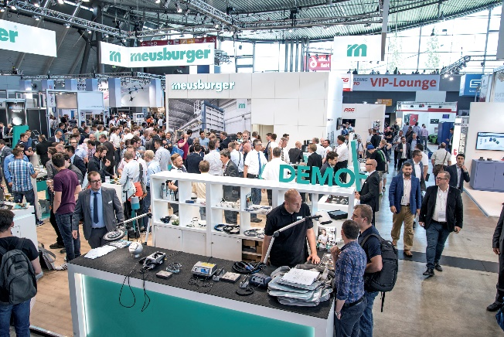
The Meusburger Group presents tried and trusted as well as new products at the Moulding Expo 2019.

Press contact

Meusburger Georg GmbH & Co KG
Communication / Public relations
Phone: +43 5574 6706-0
Email: presse@meusburger.com
www.meusburger.com
Meusburger Group

The Meusburger Group is the leading international manufacturer of high-quality products for die, mould, and jigs and fixtures construction. The continuous availability of all products makes the Meusburger Group the powerful and reliable partner in the industry. The group helps its customers to achieve sustainable success along the entire value chain. This enables them to efficiently manufacture moulds and dies as well as jigs and fixtures with the shortest lead times and constant high quality.

