Meusburger Georg GmbH & Co KG
Kesselstr. 42, 6960 Wolfurt, Austria

Meusburger presents the smallest ready-to-use slide unit on the market

The new member of the Meusburger family of compact slide units is the E 3310 TT-Slide unit, which features a compact design. The ready-to-use slide unit reduces overall costs during design and tool manufacturing. In addition, daily work is facilitated through the compatibility of the components and the direct download of CAD data including installation spaces. Small slide units are in particular demand for complex moulds.

With its compact design, the new TT slide unit offers minimum installation spaces. The term TT comes from the T-guides in the slide and cotter. This type of guide guarantees optimal force transmission at high injection pressures through the surface contact. The DLC coated slide – out of steel grade 1.2343 with 52 HRC – not only offers a high wear resistance but also best sliding properties. Due to the ESR grade the slides are excellent for mirror polishing. The supplied buffer stops the small slide safely and precisely, even with the highest dynamics. This function can also be implemented directly in the insert or in the cavity plate to save space, which makes previously unrealisable projects such as slides in change moulds possible. In addition, the slide and guide can be installed and removed together. The new TT slide unit is available with slide surfaces 12x10 mm and 15x12 mm. The CAD data is immediately available for download and additional installation spaces can be generated.

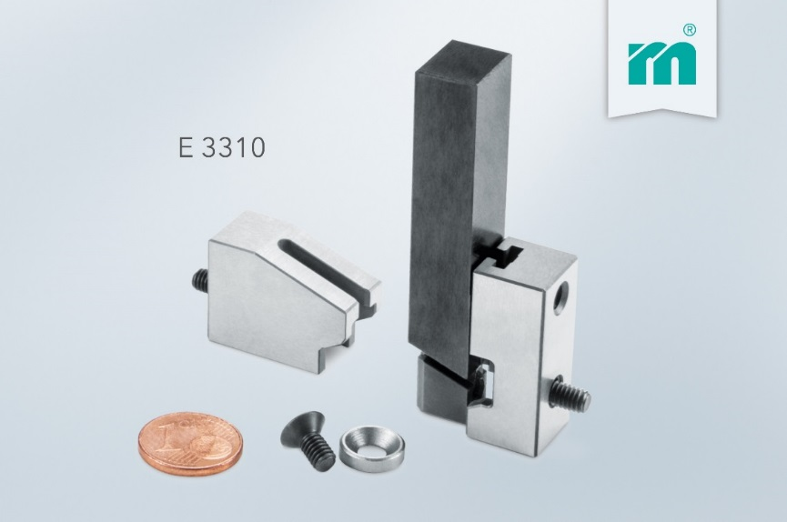
Picture credits: Photo (Meusburger)
Caption: New member of the Meusburger family of compact slide units: the E 3310 TT Slide unit.

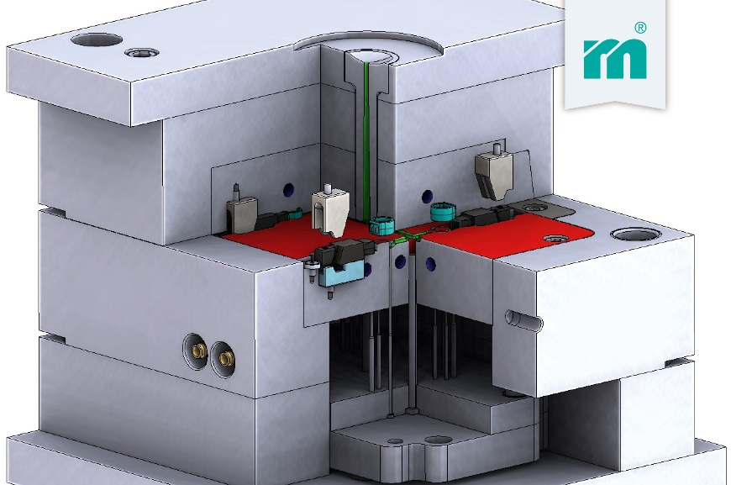
Picture credits: Photo (Meusburger)
Caption: Installation situation of the new TT slide unit in the FW-Change mould

Meusburger – Setting Standards

As a part of the Meusburger Group, the Meusburger company is the market leader in the field of high-precision standard parts. Customers all over the world make use of the advantages of standardisation and benefit from the company's over 50 years of experience in working with steel. Offering an extensive range of standard parts, combined with selected products in the field of workshop equipment, Meusburger is the reliable global partner for making moulds, dies, jigs and fixtures.

Further information:
Meusburger Georg GmbH & Co KG
Communication / Public relations
Eveline Steurer
Phone: + 43 5574 6706-1471
Email: press@meusburger.compresse@meusburger.com
http://www.meusburger.com/en/press/press.html

