PRESS RELEASE
Wolfurt, on 21.11.2019

New functions for the tried and trusted profiTEMP+
Meusburger presents its front runner in the area of control systems, the profiTEMP+, with additional functions. The new connection for an RFID reader is the perfect solution for Industry 4.0. In addition, the newly implemented setup wizard greatly simplifies the setup of the hot runner controller. EUROMAP 82.2 will also be fully supported in the future.

Thanks to Industry 4.0, production processes are more efficient, flexible, transparent and also cost-reducing. The profiTEMP+ with a connection for an RFID reader is a solution for practical application. Injection moulding machines are automatically identified and localised via the RFID reader without contact. To ensure consistent part quality, the hot runner controller must be set to the corresponding parameters which in turn are loaded fully automated. In addition, it is possible for the production department to freely select one of the injection moulding machines if the mould data is managed centrally on the device server. Quality relevant data is centrally recorded and secured. Existing moulds can be retrofitted.

Step by step instructions in the setup wizard
The update for the profiTEMP+ includes the setup wizard. This new function supports the user when setting up the hot runner controller. It also serves as an aid in determining the optimum setting parameters for the new hot runner to be set up in the shortest possible time. The setup wizard identifies and analyses the zones of the hot runner. That way less experienced operators receive suggestions for correct setting parameters which they can take into consideration along with their own specifications. Along with zone identification (manifold/nozzle recognition) and group formation, the operator can define the heating method and also define zone names, setpoint values and limit values. At the end, the setting parameters are saved on the device. During the MoldCheck, a complete test of the electrical condition of the hot runner and the wiring is performed and documented. This procedure also ensures that all protection and safety functions integrated in the profiTEMP+ are activated. The setup wizard is pre-installed on newly supplied devices. For devices with an older software version, the update can be downloaded free of charge from the website and easily carried out using a USB stick on the device.

Data exchange via OPC Unified Architecture
The profiTEMP+ hot runner controller fully supports EUROMAP 82.2. This standard describes the interface between injection moulding machines and hot runner controllers for data exchange. It is based on the OPC Unified Architecture Interface (OPC UA), a communication standard for secure and reliable data exchange in the area of industrial automation. In the future, OPC UA will be a standard interface for injection moulding machines and hot runner devices from all manufacturers to ensure compatibility.
Existing profiTEMP+ devices can be retrofitted with EUROMAP 82.2 by a free, simple software update for OPC UA.

Transparent and complete documentation
The multitude of data interfaces and protocols available in profiTEMP+ enables connectivity to machine controls, process control systems, process data acquisition systems or established process optimisation systems. In addition, there is access to all parameters of the configuration and processes, which makes the procedures considerably more transparent. The result is complete documentation of the injection moulding process - shot by shot down to the last bit. The Ethernet interface provides direct access to the controller via the internet. This ensures worldwide service from experts via the QuickSupport tool.

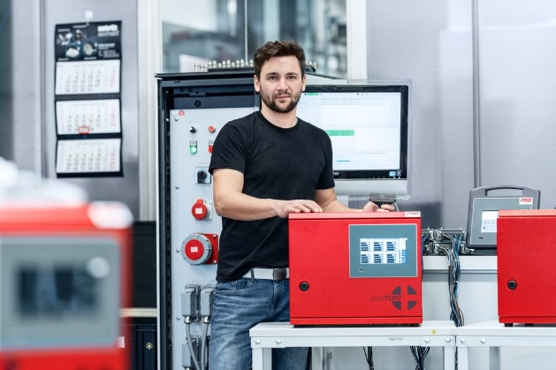

Caption: The profiTEMP+ now offers additional functions.

Image source: Meusburger publication free of charge

Press contact

Meusburger Georg GmbH & Co KG
Communication / Public relations
Phone: +43 5574 6706-0
Email: press@meusburger.com
www.meusburger.com

