Meusburger Georg GmbH & Co KG
Kesselstr. 42, 6960 Wolfurt, Austria

The largest range of temperature regulation solutions for mould making

Meusburger is constantly expanding its range of temperature regulation solutions, which leads to a higher level of safety in operation as well as savings in time during the design and use. New in the range are temperature regulation components with sealant, plug-in type bridges and the Stäubli RMI Multi coupler system.

Save time using temperature regulation components with sealant
The already applied sealant ensures shorter assembly times, since the user is spared the laborious application of the sealing bands. In addition, thanks to the reliable sealing, leakage is prevented up to 150°C. The new temperature regulation components are available in the standard coupling system as E 2000 D fitting with free flow and as E 2020 D in the shut-off variant. For reliable sealing of cooling circuits, Meusburger offers the E 2074 tapered screw plug with sealant.

Plug-in type bridges
The plug-in type bridges are now also available as E 2828 for the RPL-Stäubli system and E 2390 for the USA system. This saves time during mould assembly and enables easy deflection of cooling channels on the mould. The extension tube can be easily cut to length and individually adjusted to the bridge length.

Shortest tool change times and highest process reliability
The RMI multi coupler system from Stäubli consists of a mould side and a machine side. The E 2830 Multi coupler on the mould side is mounted on the mould base and connected to the individual fittings. This spares the user the time-consuming task of connecting every single cooling circuit for every startup of the mould. The E 2833 Multi coupler on the machine side offers different connection options for coolant hoses. It connects to the temperature control unit and ensures quick and trouble-free coupling in one work step. The automatic locking during the coupling and the anti-twist design guarantee highest safety during the operation.
As usual with Meusburger, all temperature regulation solutions described above are available from stock. The CAD data is available in the web shop with just a few clicks.

Picture credits: Photo (Meusburger)
Caption: Meusburger offers the largest range of temperature solutions for mould making

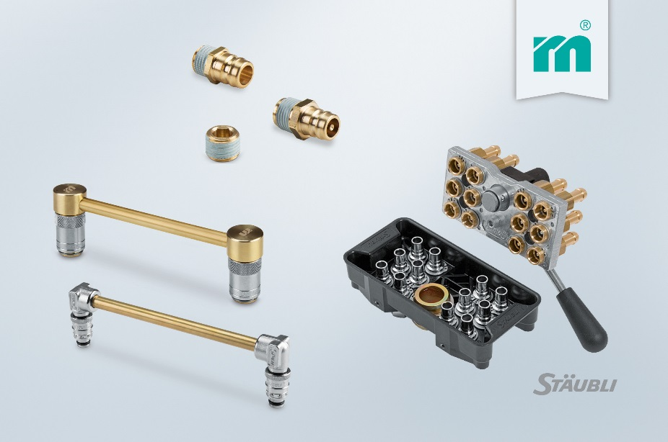

Meusburger Group – Setting Standards

The Meusburger Group is the leading international manufacturer of high-quality standard parts, hot runner and control systems and selected items in workshop equipment. More than 18,500 customers all over the world make use of the numerous advantages of standardisation and benefit from the company's over 50 years of experience in working with steel. The permanent availability of products makes the Meusburger Group the reliable and global partner for die, mould, and jigs and fixtures construction.

Further information:
Meusburger Georg GmbH & Co KG
Communication / Public relations
Lia Klimmer
Phone: + 43 5574 6706-1446
Email: press@meusburger.compresse@meusburger.com
http://www.meusburger.com/en/press/press.html

