PRESS RELEASE
Wolfurt, on 22.10.2021

Meusburger highlights at Fakuma

From the 12–16 October Meusburger was represented at Fakuma, the international trade fair for plastics processing in Friedrichshafen, Germany. The range for injection moulders as well as the standard and custom hot runner systems were in the spotlight. The visitors in hall A2 at stand 2313 and 2317 also got the first look at Meusburger’s brand new trade fair stand design. Another particular highlight at the stand was the Engel injection moulding machine, which visitors were able to watch live in action producing bread boxes.

Benefit from Meusburger’s range for injection moulders
There was a particular focus on the range for injection moulders at this year’s Fakuma. Two things are essential for reliable and smooth operation: the use of high-quality moulds and the fast delivery of replacement parts. Meusburger offers a wide range of over 96,000 items of high quality and functionality. In addition, all items are immediately available from stock. This saves customers time and money when purchasing and operating. At www.meusburger.com/injection-moulders Meusburger also has an area on their website especially for injection moulders, which provides optimal support for customers in keeping an overview of the wide product range.

Highly standardised and custom solutions for hot runner systems
Hot runner systems also played a big role at the Meusburger stand for this year’s Fakuma. The standard parts manufacturer’s hot runner system experts have over 55 years of extensive experience with complicated applications and their requirements, including physical properties, materials, functional integration, surface quality and complicated designs. Meusburger offers both standardised hot runner systems and also customised solutions. From the engineering and design phase to commissioning through to maintenance, Meusburger customers are supported throughout the entire process and receive feedback within 24 hours in every phase of the project. The visitors at this year’s Fakuma were able to speak to the field engineers at the Meusburger stand and find out about the extensive hot runner range.

Digital tools to simplify your everyday work
A further highlight at the newly designed trade fair stand was the special area for designers, where the functions and areas of the Meusburger online world were also presented. Visitors had the opportunity, for example, to take a look at the wizards and configurators for mould bases, which make it possible to assemble compatible plates, calculate the corresponding components and export the CAD data.

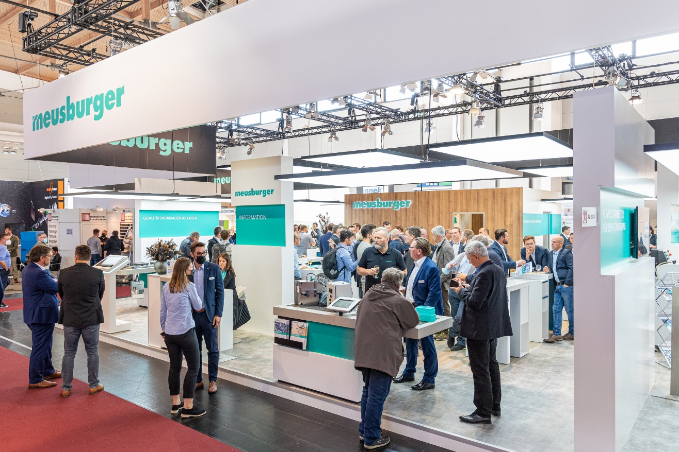
Caption: Meusburger presents highlights at the Fakuma 2021.
Image source: Meusburger publication free of charge

Meusburger – Setting Standards.

Meusburger is the market leader in the field of high-precision standard parts. Customers all over the world make use of the advantages of standardisation and benefit from the company’s over 55 years of experience in working with steel. The product portfolio ranges from high-precision standard parts and selected products in the field of workshop equipment to hot runner and control systems, the WBI Knowledge Management Method and solutions for efficient corporate management in the ERP/PPS software area. This makes Meusburger the reliable global partner for making moulds, dies, jigs and fixtures.

Press contact

Meusburger Georg GmbH & Co KG
Communication / Public relations
Phone: +43 5574 6706-0
Email: press@meusburger.com
www.meusburger.com

