Press Release
Wolfurt, 23.04.2019

Offset cutting punches at Meusburger

With the offset cutting punches from Meusburger there are many possibilities to configure the contour of cutting punches individually according to your needs. In addition, different materials and head shapes as well as coatings are available. These can be selected quickly and easily using the cutting punches configurator. Thanks to in-house production, Meusburger offers maximum precision and short lead times.

Five different contours
There are five different contours to choose from: round offset, oblong hole, rectangle, hexagon, and round flat. Anti-rotation protection on the head with optionally 0° or 90° to the contour can also be selected.

Different materials and head shapes
In order to meet different requirements when selecting the material of the cutting punch, Meusburger offers the offset cutting punches in the materials 1.3343 (HSS) and 1.3344 (PM23).
The cutting punches are available with cylindrical, conical, as well as bottle-neck head shapes. For the selection of the correct head shape, the space requirement of the head and the retracting forces during the stamping process are decisive.

Coating for maximum service life
With the TiN and AlCrN coating, a considerably longer service life can be achieved due to the greatly reduced abrasive and adhesive wear. In addition, the coating reduces the coefficient of friction, which in turn reduces the stamping and retracting forces.

Custom design with the cutting punches configurator
With the cutting punches configurator, the standard parts manufacturer offers a simple and time-saving way to design cutting punches individually. The configurator can be accessed in the Meusburger web shop and offline shop. First the head shape, material and coating are selected, as well as the desired contour and also ejector and anti-rotation protection if required. Then the diameter and total length can be selected and the dimensions of the cutting geometry and cutting edge length can be entered. If a total length deviating from the standard is required, it is also possible to enter an individual value. With just a few clicks, the cutting punch is then adapted to your personal requirements and exported to the CAD system as a completely configured component.

In-house production ensures short lead times
To guarantee maximum precision in the stamping process, production with tight tolerances is a top priority at Meusburger. In-house production using an automated cylindrical grinding machine guarantees short lead times. In addition, a comprehensive range of round offset cutting punches are available from stock.

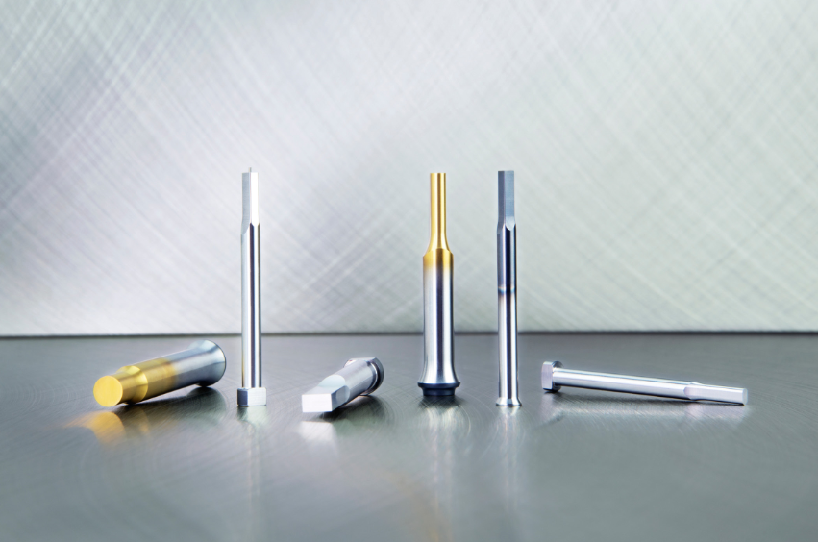
Image source: Meusburger, publication free of charge
Caption: Offset cutting punches at Meusburger

Meusburger – Setting Standards.

As a part of the Meusburger Group, the Meusburger company is the market leader in the field of high-precision standard parts. 21,000 customers all over the world make use of the advantages of standardisation and benefit from the company's over 50 years of experience in working with steel. Offering an extensive range of standard parts, combined with selected products in the field of workshop equipment, Meusburger is the reliable global partner for making moulds, dies, jigs and fixtures.

Press contact

Meusburger Georg GmbH & Co KG
Communication / Public relations
Phone: +43 5574 6706-0
Email: presse@meusburger.com
www.meusburger.com

