Meusburger Georg GmbH & Co KG
Kesselstr. 42, 6960 Wolfurt, Austria

New configuration options for Meusburger cutting punches

The standard parts manufacturer Meusburger now offers new configuration options for cutting punches. This includes two different PVD coatings for maximum service life and the configuration of anti-rotation protection for shape punches. The cutting punches can be quickly and easily selected via the new configurator in the Meusburger digital catalogues.

Meusburger now offers its cutting punches with both TiN and AlCrN coating. This results in a significantly longer service life. In addition the coating reduces the coefficient of friction which results in lower stamping and retracting forces. A further innovation is the precise anti-rotation protection for shape punches with cylindrical head. An exact positioning of the punch is ensured through a parallelism of 0.01 mm between anti-rotation protection on the head and contour. The anti-rotation protection can be 0° or 90° to the contour which enables a flexible installation in the die set. Short lead times are guaranteed through the in-house production.
With the new cutting punches configurator, the standard parts manufacturer offers an easy and time-saving option for the individual design of the cutting punches. This can be accessed from the Meusburger digital catalogues. First the head shape, material, coating and the desired contour with the appropriate anti-rotation protection are selected. Then the diameter, total length, dimensions of the cutting geometry and the cutting edge length can be entered. With just a few mouse clicks the cutting punch can be adapted to the individual requirements and exported to the CAD system as a fully configured component.

Picture credits: Photo (Meusburger)
Caption: New configuration options for Meusburger cutting punches

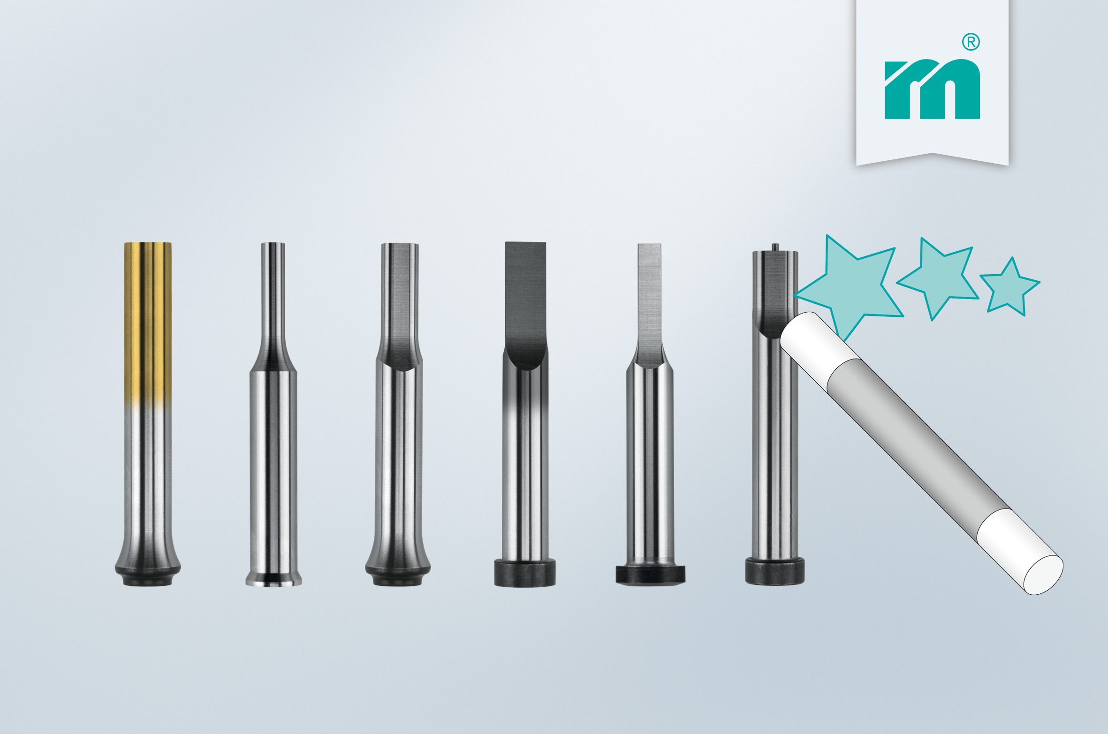

Meusburger – Setting Standards
Meusburger is the leading manufacturer of high-precision standard parts. More than 17,000 customers all over the world make use of the numerous advantages of standardisation and benefit from the company's over 50 years of experience in working with steel. Offering an extensive range of standard parts, combined with high-grade products in the field of workshop equipment, Meusburger is the reliable global partner for making dies, moulds, jigs and fixtures.

Further information:
Meusburger Georg GmbH & Co KG
Communication / Public relations
Lia Klimmer
Phone: + 43 5574 6706-1446
Email: presse@meusburger.compresse@meusburger.com
www.meusburger.com/press-releases

