Meusburger Georg GmbH & Co KG
Kesselstr. 42, 6960 Wolfurt, Austria

NEW from Meusburger - Adjustment unit with even more precise positioning

The E 5660 Adjustment unit enables fast and exact adjustment of stamping and bending elements. Its compact fitting dimensions allow for flexible positioning inside the stamping die. In addition, the new adjustment angle ensures an even more precise positioning of 0.05 mm per screw rotation.

The time-consuming adjustment and high costs for the design and manufacture of customised adjustment units are now a thing of the past: the standardised E 5660 Adjustment unit from Meusburger makes it easy to adjust the stamping and bending elements both quickly and accurately. Its compact fitting dimensions and the screws in different lengths allow for a flexible positioning of the adjustment unit inside the die. With the precisely coordinated adjustment wedge, a defined adjustment travel per screw rotation is guaranteed. In addition to the existing adjustment unit - with an adjustment of 0.1 mm per rotation - Meusburger now offers an additional model with an adjustment of 0.05 mm per rotation. This enables even more precise adjustment. The CAD data of the adjustment unit can be downloaded from the online shop and the CD catalogue with just a few mouse clicks. As usual with Meusburger, the adjustment unit is immediately available from stock.

Picture credits: Photo (Meusburger)
Captions: NEW from Meusburger - Adjustment unit with even more precise positioning

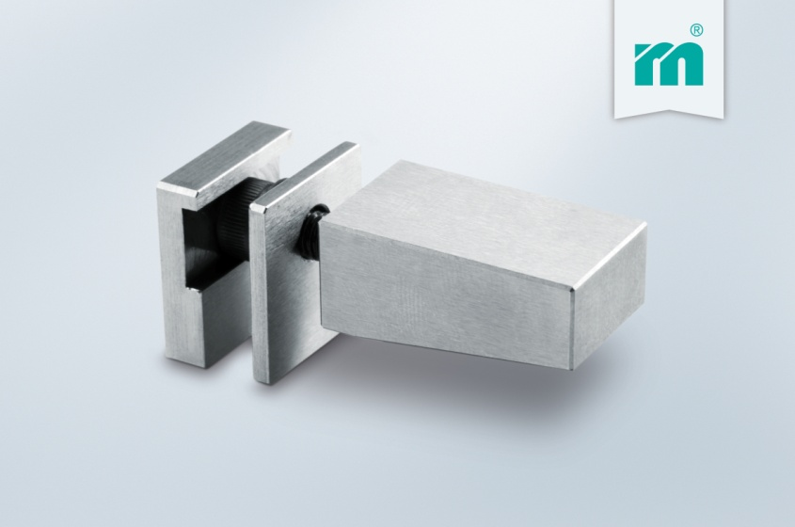

Meusburger – Setting Standards
Meusburger is the leading manufacturer of high-precision standard parts. More than 17,000 customers all over the world make use of the numerous advantages of standardisation and benefit from the company's over 50 years of experience in working with steel. Offering an extensive range of standard parts, combined with high-grade products in the field of workshop equipment, Meusburger is the reliable global partner for making dies, moulds, jigs and fixtures.

Further information:
Meusburger Georg GmbH & Co KG
Communication / Public relations
Phone: + 43 5574 6706-0
Email: press@meusburger.com
www.meusburger.com/press-releases

