Meusburger Georg GmbH & Co KG
Kesselstr. 42, 6960 Wolfurt, Austria

Efficiency in machine and jig construction
Meusburger at EMO 2017

From September 18th to 23rd 2017, EMO, the trade fair for metalworking, opens its doors in Hannover. Meusburger will also be represented this year in Hall 5 at Stand E 24 and informing visitors about its wide range of products as well as the advantages of standardisation in machine and jig construction.

Competitive advantages with heat treated for stress relief semi-finished products
The trend towards standardisation is taking more and more hold in machine and jig construction. A logical development, considering that with the progressing globalisation, ever shorter project lead times and efficiency improvements are required in order to survive on the international market.
Therefore Meusburger offers a comprehensive range of semi-finished products – from heat treated for stress relief plates and bars from stock to special plates. The precisely prefabricated plates and bars can be delivered to Germany, Austria and Switzerland within 24 hours. In addition, all products for machine and jig construction are available in different material grades and variations.

Manufacturing technologies at Meusburger
Meusburger offers a variety of manufacturing technologies like flame cutting, sawing, deep hole drilling, milling, grinding or turning. The web shop enables quick and easy calculation and design. Through the prefabricated flame-cuts plates and milling service, customers can save their resources and concentrate on their own core competences. At the EMO, visitors have the opportunity to have a close look at samples from the different manufacturing technologies.

Trade fair highlights of EMO
The digital wizards as well as the web shop can be tried out at the information terminals at the Meusburger trade fair stand. In addition to the web portal Meusburger offers the well-arranged print catalogue ‘Plates & Bars 2016/2017’ which displays the complete standard parts range as well as additional information such as the CAD standards or comparison and tolerance tables.

We are looking forward to your visit at EMO in Hall 5 at Stand E 24

Picture credits: Photo (Meusburger)
Caption: The Meusburger stand – always worth a visit

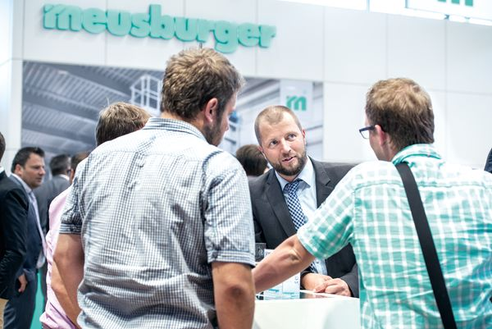

Meusburger – Setting Standards
The Meusburger Group is the leading international manufacturer of high-quality standard parts, hot runner and control systems and selected items in workshop equipment. More than 17,500 customers all over the world make use of the numerous advantages of standardisation and benefit from the company's over 50 years of experience in working with steel. The permanent availability of products makes the Meusburger Group the reliable and global partner for die, mould, jigs and fixtures construction.

Further information:
Meusburger Georg GmbH & Co KG
Communication / Public relations
Lia Klimmer
Phone: + 43 5574 6706-1446
Email: presse@meusburger.compresse@meusburger.com
http://www.meusburger.com/en/press/press.html

