Meusburger Georg GmbH & Co KG
Kesselstr. 42, 6960 Wolfurt, Austria

A must-have in modern die and mould making: DLC coated components

Moving components without hard carbon coating (diamond-like carbon, or DLC for short) can hardly be imagined in modern die and mould making. But what is so good about this coating? Through examples, Meusburger shows the clear advantages and uses of DLC coated standard components.

Particularly in injection moulding, many moving components are DLC coated. Whether sliding surfaces on guide pillars, slides or ejectors - DLC coating reduces both wear and corrosion, and ensures significantly better dry-running or emergency operating properties. This means a longer service life with less maintenance, and therefore a clear opportunity for increased productivity.

Composition and characteristics of a DLC coating

The coating is largely made up of the chemical element carbon. It consists of an adhesive coat and a carbon coat.

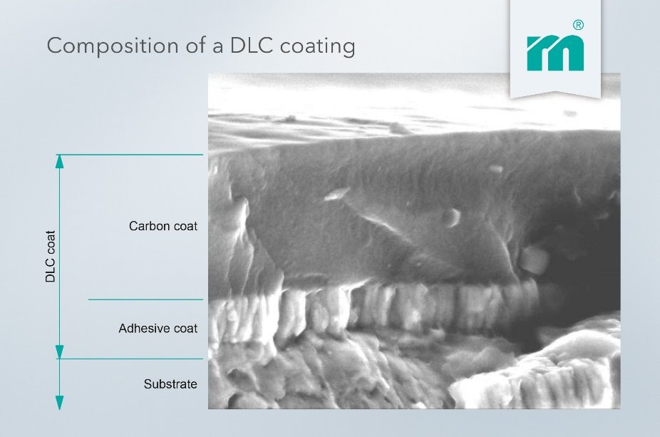

- DLC coating thickness: ~ 2 μm
- Hardness: ~ 3000 HV
- Colour: black grey
- Operating temperature: max. 350°C
- Coefficient of friction against steel: 0.1 – 0.15
- Coating temperature: <180°C

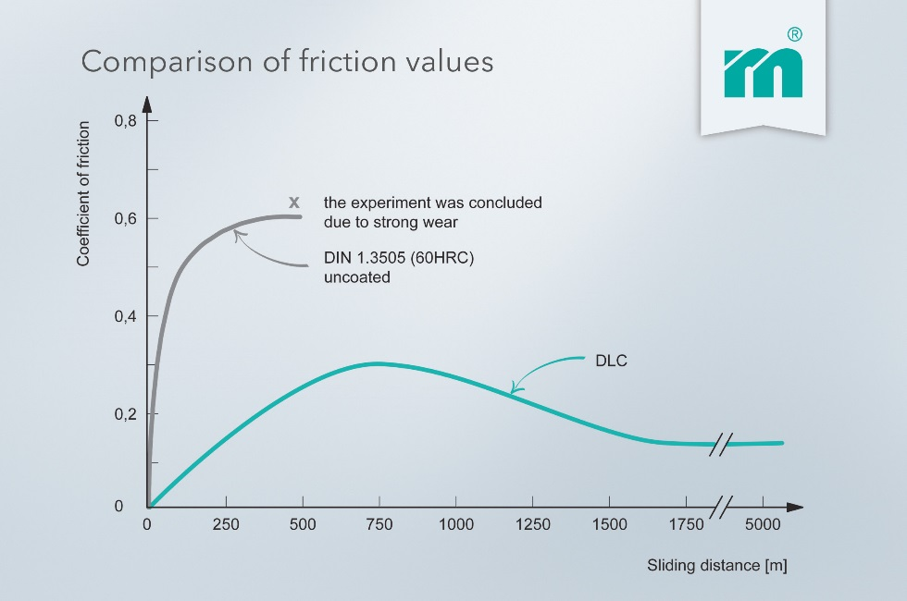

Areas of application for DLC coated Meusburger standard components

Guiding and centring
Guiding elements and particularly centring elements endure high wear through the friction from the opening and closing of the mould. The DLC coating offers the best sliding properties and minimises adhesive wear. This ultimately lengthens the intervals between lubrication and leads to a longer service life for the mould.

Slides
Lubrication close to the cavity often leads to grease residues on the plastic part. Thanks to the best dry-running properties of DLC coated sliding surfaces, lubrication in these areas can be left out completely.

Ejectors
Targeted lubrication of ejectors can be quite tedious thanks to the often limited accessibility. This can lead to a lack of lubrication and ultimately to fretting of the ejectors. DLC coated ejectors are the ideal way to avoid this, thanks to their excellent dry-running properties and high corrosion resistance. These are also optimal prerequisites for use in a cleanroom.

Components for demoulding
In order to meet the high mechanical demands of the switching elements on latch locks, these are DLC coated. This enables an even longer service life.
Due to the DLC coated sliding elements, the maintenance intervals for lubrication for two-stage ejectors is lengthened from 100,000 strokes to 300,000 strokes.

Our conclusion: DLC coated standard components are slightly more expensive, but the investment quickly pays off through higher productivity.

Picture credits: Graphics (Meusburger)
Caption: -

Meusburger – Setting Standards

As a part of the Meusburger Group, the Meusburger company is the market leader in the field of high-precision standard parts. Customers all over the world make use of the advantages of standardisation and benefit from the company's over 50 years of experience in working with steel. Offering an extensive range of standard parts, combined with selected products in the field of workshop equipment, Meusburger is the reliable global partner for making moulds, dies, jigs and fixtures.

Further information:
Meusburger Georg GmbH & Co KG
Communication / Public relations
Lia Klimmer
Phone: + 43 5574 6706-1446
Email: press@meusburger.compresse@meusburger.com
http://www.meusburger.com/en/press/press.html

