Meusburger Georg GmbH & Co KG
Kesselstr. 42, 6960 Wolfurt, Austria

NEW from Meusburger: E 5636 Strip guiding rail in lengths 60 and 100 mm

Especially for long side cut-outs, a longer strip guiding rail is necessary in order to completely cover the cut-outs and therefore prevent the lifting-off of the strip. For this reason, Meusburger now offers the E 5636 Strip guiding rail in the additional lengths 60 and 100 mm. Thanks to the quick installation directly from the working plane the time needed for assembly and removal of the stamping die can be significantly reduced. The strip guiding rails are hardened to 60 HRC and therefore offer excellent wear protection. The integrated infeed chamfers on all sides ensure easy entry of the strip, as well as making it possible to use both sides of the guiding rail. This prevents incorrect installation. The strip guiding rail is also available from stock in length 30 mm. For all lengths there are various heights ranging from 4 to 20 mm.

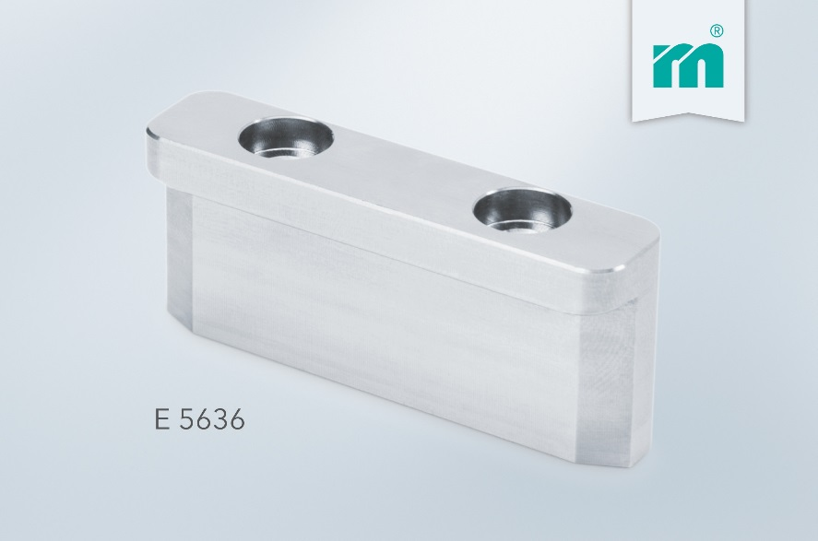

Picture credits: Photo (Meusburger)
Caption: NEW from Meusburger: E 5636 Strip guiding rail in lengths 60 and 100 mm

Meusburger – Setting Standards

As a part of the Meusburger Group, the Meusburger company is the market leader in the field of high-precision standard parts. Customers all over the world make use of the advantages of standardisation and benefit from the company's over 50 years of experience in working with steel. Offering an extensive range of standard parts, combined with selected products in the field of workshop equipment, Meusburger is the reliable global partner for making moulds, dies, jigs and fixtures.

Further information:
Meusburger Georg GmbH & Co KG
Communication / Public relations
Eveline Steurer
Phone: + 43 5574 6706-1471
Email: press@meusburger.compresse@meusburger.com
http://www.meusburger.com/en/press/press.html

