Meusburger Georg GmbH & Co KG
Kesselstr. 42, 6960 Wolfurt, Austria

Stamps with latching function for even higher process reliability

Marking stamps are used for clear marking of injection-moulded parts. To prevent unintended movement of the arrow insert, Meusburger now offers stamps with a latching function. These ensure even higher process reliability during the injection moulding process, and prevent parts being marked incorrectly.

The latching of the arrow insert into defined positions guarantees that the arrow remains in a fixed position. The main body of the stamp also remains at the same height as the arrow insert (therefore named ‘with fixed height’). The stamp can be easily removed at the split line face thanks to a withdrawal thread in the main body. Made of stainless steel 1.4112 with a hardness of 52 HRC, the stamp can be used at temperatures up to 340°C. Thanks to the low installation height, it is also optimally suited for installation in very thin moulding plates. The new stamp is available in different variations: month (E 2420 R), year (E 2424 R), 0-9 (E 2422 R) as well as a blank main body for individual configuration (E 2429 R). The diameters range from 4 to 12 mm. As usual, the CAD data is available in the Meusburger web shop with just a few clicks.

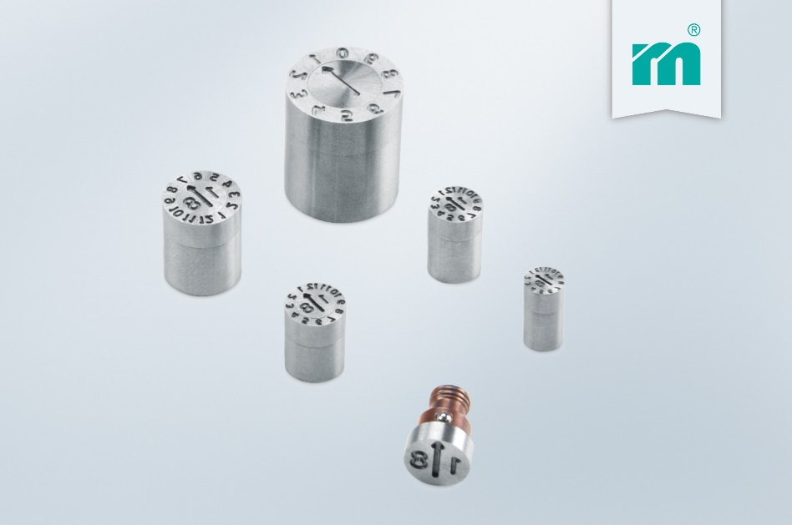

Picture credits: Photo (Meusburger)
Caption: Stamps with latching function for even higher process reliability

Meusburger – Setting Standards.

As a part of the Meusburger Group, the Meusburger company is the market leader in the field of high-precision standard parts. Customers all over the world make use of the advantages of standardisation and benefit from the company's over 50 years of experience in working with steel. Offering an extensive range of standard parts, combined with selected products in the field of workshop equipment, Meusburger is the reliable global partner for making moulds, dies, jigs and fixtures.

Further information:
Meusburger Georg GmbH & Co KG
Communication / Public relations
Lia Klimmer
Phone: + 43 5574 6706-1446
Email: press@meusburger.compresse@meusburger.com
http://www.meusburger.com/en/press/press.html

