Meusburger Georg GmbH & Co KG
Kesselstr. 42, 6960 Wolfurt, Austria

Clamping devices for ergonomic work during polishing

Ergonomics plays a central role in the design of a safe and healthy working environment in many areas. With the new tiltable tables and magnetic clamping balls, which enable ergonomic work during polishing, the standard parts manufacturer expands its workshop equipment range and makes an important contribution for modern workplace design.

HPO 1100 – Manually operated tiltable table

The tiltable table can be easily pivoted using the handle and turned and fixed in the desired position by hand. The workpiece can therefore be brought to any desired position. Either a clamping plate with a 400 mm diameter or a round magnet with 160 mm diameter can be clamped on the tiltable table. Therefore many different mould sizes can be clamped. The round magnet can be switched on and off as needed. The tiltable table can be securely screwed onto the work station.

HPO 1200 – Tiltable table with rotary drive

The tilting movement is controlled by the handle, the rotational movement is generated through the motor drive. Through the uniform speed, especially rotation-symmetric components can be machined. The speed can be preset to a value between 3.7 and 37 rpm. A foot switch is available optionally, to control not only the switching on and off but also the direction of the rotary movement. Here too, it is possible to choose between a clamping plate or round magnet.

HPO 4400 – Magnetic clamping ball

The HPO 4400 Magnetic clamping ball has been available at Meusburger since January 2017. The ball can rotate and swivel in all directions which makes it the perfect device for placing parts such as inserts and smaller moulding plates in any position. The magnet can be switched on and off easily using a hexagon key. The ball is held in position by stick-slip effect. The customer can choose between 4 different sizes.

The tiltable tables as well as the magnetic clamping ball are available from stock at Meusburger.

Picture credits: Photo (Meusburger)
Caption: Tiltable table for ergonomic work during polishing

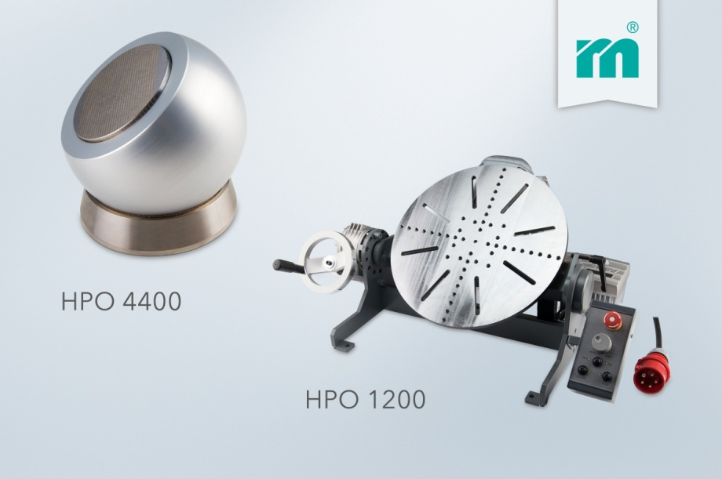

Meusburger Group – Setting Standards
The Meusburger Group is the leading international manufacturer of high-quality standard parts, hot runner and control systems and selected items in workshop equipment. More than 17,500 customers all over the world make use of the numerous advantages of standardisation and benefit from the company's over 50 years of experience in working with steel. The permanent availability of products makes the Meusburger Group the reliable and global partner for die, mould, jigs and fixtures construction.

Further information:
Meusburger Georg GmbH & Co KG
Communication / Public relations
Lia Klimmer
Phone: +43 5574 6706-1446
Email: presse@meusburger.com
www.meusburger.com/press-releases

