Meusburger Georg GmbH & Co KG
Kesselstr. 42, 6960 Wolfurt, Austria

NEW – Meusburger cutting punches with configurable bases

Since October the standard parts manufacturer Meusburger offers cutting punches with freely configurable bases. The bases are specially manufactured to the customers' requirements with square, rectangular, and oblong cross sections. Short lead times are guaranteed by in-house production.

In the area of cutting elements Meusburger expands its range with cutting punches with freely configurable bases. As of now the cutting punches are available with bases in square, rectangular, and oblong cross sections with different head shapes to select from. In the online shop the desired cutting punch can be configured with just a few mouse clicks. After selecting the appropriate cutting punch the dimensions of the cutting geometry and the cutting edge length are entered. The CAD data is also available for download. To guarantee maximum precision in the stamping process great importance is attached to the tight tolerances during the production. Meusburger guarantees short lead times through the in-house production on an automated cylindrical grinding machine.

Picture credits: Photo (Meusburger),
Captions: NEW – Meusburger cutting punches with configurable bases

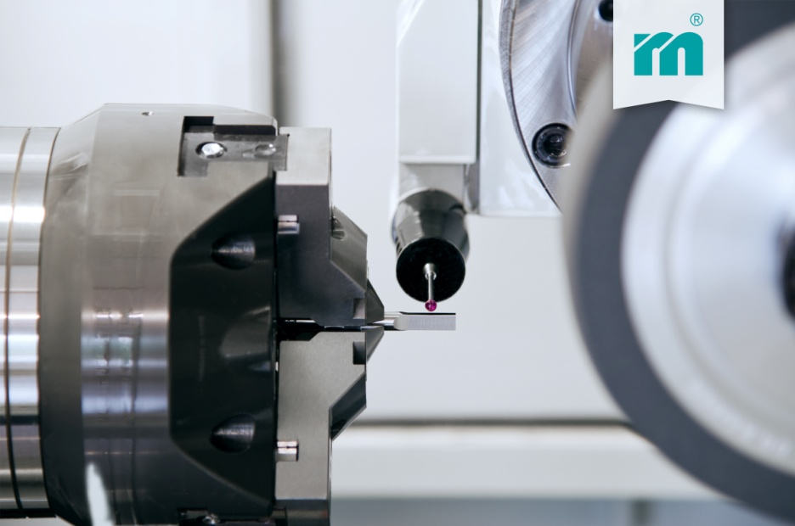

Meusburger – Setting Standards
Meusburger is the leading manufacturer of high-precision standard parts. More than 17,000 customers all over the world make use of the numerous advantages of standardisation and benefit from the company's over 50 years of experience in working with steel. Offering an extensive range of standard parts, combined with high-grade products in the field of workshop equipment, Meusburger is the reliable global partner for making dies, moulds, jigs and fixtures.

Further information:
Meusburger Georg GmbH & Co KG
Communication / Public relations
Phone: 0043 (0) 5574 6706-0
Email: presse@meusburger.com
www.meusburger.com/press-releases

