PRESS RELEASE
Wolfurt, on 13.02.2020

Milling cutters especially for hard machining from Meusburger

Meusburger offers the optimal solutions for machining hardened material up to 67 HRC. The hard milling cutters in different variations achieve highest precision and quality. Most milling cutters are used in Meusburger’s own production. This means that the range is perfectly matched to the requirements and materials in mould and die making.

Hard machining plays an important role in mould and die making but also presents a major challenge. In recent years, some progress has been made in this area with the development of milling tools. As an alternative to time-consuming EDM and grinding, in some cases milling enables a faster, more precise and economical process. Since accuracy and precision are particularly important, milling cutters need to meet high requirements and deliver high quality. Meusburger has recognised these needs and offers the optimal solution: a selection of special tools for machining hardened material, which includes cutters suitable for milling operations. Why is Meusburger convinced of their quality? Because we rely on most of the milling cutters in our own production and put them to the test ourselves! This not only gives us experience with the tools, but also provides us with cutting parameters which we pass on directly to the customer via our cutting data calculator (https://schnittdaten.meusburger.com/calculator/milling/).

Milling cutters as a suitable solution for hard machining
A variety of workpieces must still be machined after hardening, which requires special tools such as hard milling cutters. Meusburger offers hard milling cutters in various types and provides a wide range of possibilities for the customer. In addition to two different end milling cutters (WZF 135…. and WZF 137….) for the machining of materials up to 63 and 67 HRC respectively, and the high-precision micro cutters, Meusburger offers torus and full-radius milling cutters (torus WZF 174…., WZF 1757.., WZF 2779.., full-radius WZF 184…., WZF 1851.., WZF 2879..) in three different variations: up to 54, up to 63 and up to 67 HRC. The latest generation of milling cutters (up to 67 HRC) allow a wide range of materials to be machined. In addition to the new coating and new substrate, they also feature modern grinding technology and high precision. Meusburger’s hard milling cutters achieve better dimensional accuracy and a better surface on the workpiece.

Different types of indexable insert milling cutters
In addition to various hard milling cutters, Meusburger’s product range also includes indexable insert milling cutters. These are used when high repeatability is required, since the diameter and cutting data always remain the same due to the exchangeability of the indexable inserts. This has the advantage of reducing machining costs. In addition to high-feed milling cutters, round insert cutters, and shoulder milling cutters especially designed for hard machining, Meusburger offers full-radius and torus milling cutters with different variants of tool carriers: with steel shaft, with screw-in thread, and as shell-type milling cutter. Many of these tools are used in Meusburger's own production for machining hardened material. Compared to other manufacturers, the selection of the correct indexable insert is extremely simple at Meusburger: From the numerous indexable inserts available, we have done the preselection and offer in our range a variety of tools that are especially suited to the materials in mould and die making.

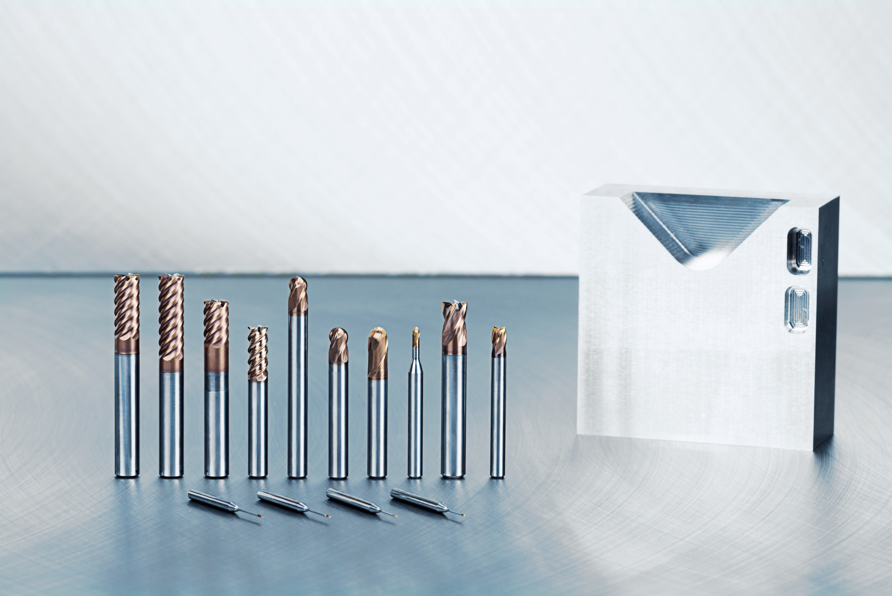

Image source: Meusburger publication free of charge
Caption:
Meusburger offers milling cutters in different variations as a suitable solution for hard machining.

Meusburger – Setting Standards.

Meusburger is the market leader in the field of high-precision standard parts. Customers all over the world make use of the advantages of standardisation and benefit from the company’s over 50 years of experience in working with steel. The product portfolio ranges from high-precision standard parts and selected products in the field of workshop equipment to hot runner and control systems, the WBI Knowledge Management Method and solutions for efficient corporate management in the ERP/PPS software area. This makes Meusburger the reliable global partner for making moulds, dies, jigs and fixtures.
Press contact

Meusburger Georg GmbH & Co KG
Communication / Public relations
Phone: +43 5574 6706-0
Email: press@meusburger.com
www.meusburger.com

