Meusburger Georg GmbH & Co KG
Kesselstr. 42, 6960 Wolfurt, Austria

Reliable demoulding of complex injection moulded parts

The compact ejector accelerator from Meusburger is the ideal device for the safe and targeted ejection of complex parts: a single ejector is additionally accelerated by which snagging of the injection moulded part is avoided. The injection pressure is absorbed by the ejector base plate thus the ejection accelerator does not bear any load and has a longer service life. Due to the small component size a flexible positioning of the ejector accelerator in the ejector set is also possible when retrofitting.

The E 1522 Ejector accelerator from Meusburger optimises the smooth ejection of injection moulded parts. With the newly developed component targeted control of the ejection process is possible. Through the additional acceleration of a single ejector snagging of the injection moulded part is avoided. The acceleration ratio is 1:1.5. Therefore a longer path is achieved with a small stroke. The repositioning of the accelerator does not take place directly through the clamp plate but through a cut to length ejector so the same buffer plates for the ejector set can be used. A further advantage is that the entire injection pressure is absorbed directly by the ejector base plate. As a result the ejector accelerator does not bear any load during the injection moulding process.
The three different sizes available allow designers to install ejectors in the diameters of 3 – 11.5 mm at will. The small component size enables a flexible positioning of the ejection accelerator in the ejector set. Therefore the ejector accelerator can also be installed quickly and easily when retrofitting the mould. In order to save design time, the installation space is already included in the CAD data. As usual with Meusburger the new component is available from stock.

Picture credits: Photo (Meusburger)
Caption: Reliable demoulding of complex injection moulded parts

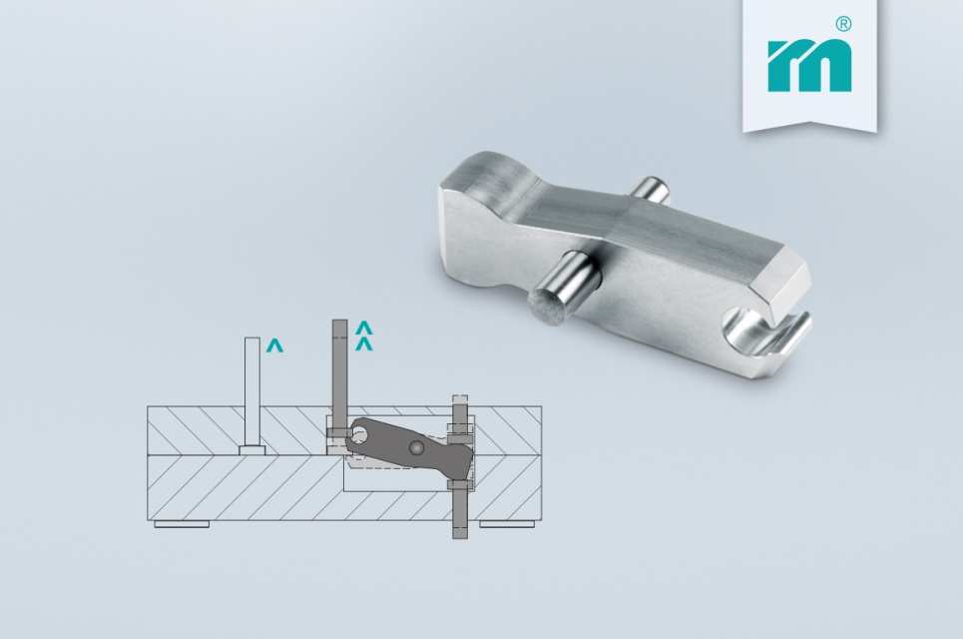

Meusburger – Setting Standards
Meusburger is the leading manufacturer of high-precision standard parts. More than 17,000 customers all over the world make use of the numerous advantages of standardisation and benefit from the company's over 50 years of experience in working with steel. Offering an extensive range of standard parts, combined with high-grade products in the field of workshop equipment, Meusburger is the reliable global partner for making dies, moulds, jigs and fixtures.

Further information:
Meusburger Georg GmbH & Co KG
Communication / Public relations
Phone: 0043 (0) 5574 6706-0
Email address: presse@meusburger.com
www.meusburger.com/press-releases

