Meusburger Georg GmbH & Co KG
Kesselstr. 42, 6960 Wolfurt, Austria

NEW in range from Meusburger – SD- and SZ-Two-pillar die sets

With the new two-pillar die sets, in which the guide pillars are arranged diagonally or centrally, Meusburger enables its customers new and flexible applications. The optimised arrangement of the retainer clip for the pillars and bushes retainer guarantees the SZ Two-pillar die set, central guiding a maximum usable width. The SD Two-pillar die set, diagonal guiding is designed for use in the length and width. Both die sets are available in the sizes 126 156 to 396 496 with or without backing plate and combinable with ball and sliding guide bushes. The anti-rotation protection takes places via the market standard diameter gradation for the guiding system. As always with Meusburger, the plates are manufactured standard with a high-precision alignment edge for exact positioning on the machines. With help of the practical wizard in the online shop the die sets can be assembled quickly and easily. In the first step the size of the die set and the type of the mould base is determined then the respective plates for pillars or bushes retainer are selected. The wizard then automatically calculates the suitable components like guide pillars, bushes, and retainer clips. The finished configurable two-pillar die set can be directly exported in the desired CAD format. The entire process only lasts a couple of minutes.

Picture credits: Photo (Meusburger),
Captions: NEW in range from Meusburger – SD- and SZ-Two-pillar die sets
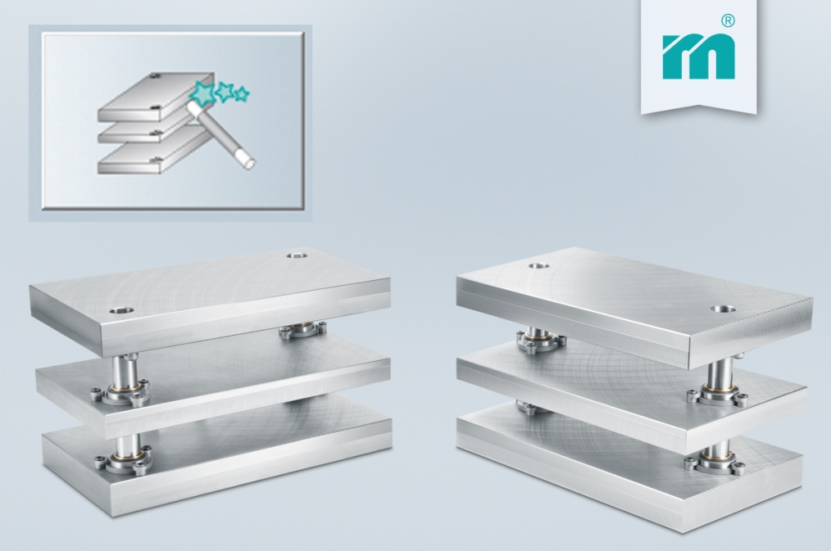

Meusburger – Setting Standards.
Meusburger is the leading manufacturer in the field of high-precision standard parts. More than 17,000 customers all over the world make use of the numerous advantages of standardisation and benefit from the company's over 50 years of experience in working with steel. Offering an extensive range of standard parts, combined with high-grade products in the field of workshop equipment, Meusburger is the reliable global partner for making dies, moulds, jigs and fixtures.

Further information:
Meusburger Georg GmbH & Co KG
Communication / Public relations
Phone: 0043 (0) 5574 6706-0
Email address: presse@meusburger.com
http://www.meusburger.com/press/press.html

