PRESS RELEASE
Wolfurt, on 07.05.2020

Meusburger premium power clamps for injection moulding

The Meusburger HWS 104 premium power clamp line features extremely robust and ergonomic design. This ensures simple, fast and reliable clamping of injection moulds and reduces your machine downtimes.

Thanks to the optimally designed Meusburger power clamp range, a large number of different moulds can be easily clamped. Even challenging clamping positions in confined spaces can be achieved without any problems due to the compact models.
The ergonomic design guarantees easy handling and allows for safe operation. The high-quality, black galvanised, quenched and tempered alloy steel ensures a long service life and optimum protection against corrosion.
Another advantage is the smooth pressure pad included in the delivery. This ensures even distribution of the contact pressure during the clamping process and also protects the mould or workpiece from damage. Alternatively, clamping without a pressure pad is also possible.
By means of the optionally available T-nuts, the power clamps can be converted in no time at all into clamping devices that can be clamped on T-slotted tables. This results in a wide range of applications, covering a large variety of areas from machining to jigs and fixtures construction.
Meusburger offers the new power clamps in seven different sizes. The clamping range extends from 12 mm to 165 mm. The clamping force is 22 kN to 49 kN, depending on the size of the power clamp.

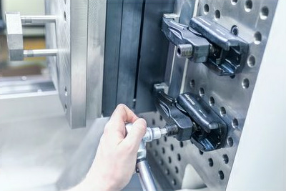
Image source: Meusburger
Caption: The new Meusburger HWS 104 premium power clamp in use

Meusburger – Setting Standards.

Meusburger is the market leader in the field of high-precision standard parts. Customers all over the world make use of the advantages of standardisation and benefit from the company’s over 55 years of experience in working with steel. The product portfolio ranges from high-precision standard parts and selected products in the field of workshop equipment to hot runner and control systems, the WBI Knowledge Management Method and solutions for efficient corporate management in the ERP/PPS software area. This makes Meusburger the reliable global partner for making moulds, dies, jigs and fixtures.

Press contact

Meusburger Georg GmbH & Co KG
Communication / Public relations
Phone: +43 5574 6706-0
Email: press@meusburger.com
www.meusburger.com

