Meusburger Georg GmbH & Co KG
Kesselstr. 42, 6960 Wolfurt, Austria

Meusburger hydraulic cylinders now with stroke of up to 200 mm

From now on the standard parts manufacturer Meusburger also offers hydraulic cylinders with a stroke of up to 200 mm available from stock. Thanks to the finely graduated stroke lengths a large application range is possible. Due to the standard lengths and transverse holes the double-acting cylinders can be flexibly installed.

Due to the countless variants which are offered on the market, the selection and configuration of the appropriate hydraulic cylinder is very time-consuming and difficult - which also affects the lead times. With a clear selection of high-quality and standardised hydraulic cylinders, Meusburger helps its customers save time and money. New in the Meusburger range is the extension of the hydraulic cylinders E 7000, E 7001 and E 7020. These are now available from stock with a stroke of up to 200 mm. A particular characteristic of the double-acting hydraulic cylinders from Meusburger are the standard axial and transverse holes. Furthermore the piston rods are hardened and ground and therefore offer optimal protection against damages and leaks. All Meusburger hydraulic cylinders are equipped with FKM (Viton®) seals enabling operating temperatures of up to 180°C. Also the matching accessories, such as couplers, magnetic proximity sensors for position monitoring and appropriate threaded fittings are offered by the standard parts manufacturer. The CAD data are available for download immediately, whereby the stroke is directly entered in the digital catalogues and then transferred to the appropriate CAD programme. As usual with Meusburger, the new hydraulic cylinders are available from stock.

Picture credits: Photo (Meusburger)
Caption: Hydraulic cylinders now available from stock with stroke up to 200 mm

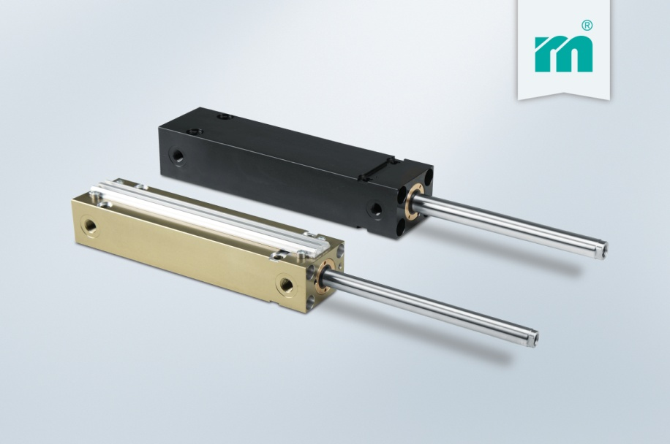

Meusburger – Setting Standards
Meusburger is the leading manufacturer of high-precision standard parts. More than 17,000 customers all over the world make use of the numerous advantages of standardisation and benefit from the company's over 50 years of experience in working with steel. Offering an extensive range of standard parts, combined with high-grade products in the field of workshop equipment, Meusburger is the reliable global partner for making dies, moulds, jigs and fixtures.

Further information:
Meusburger Georg GmbH & Co KG
Communication / Public relations
Phone: + 43 5574 6706-0
Email: press@meusburger.compresse@meusburger.com
www.meusburger.com/press-releases

