Meusburger Georg GmbH & Co KG
Kesselstr. 42, 6960 Wolfurt, Austria

Die casting components for die and mould making

Die casting moulds have to meet highest demands. In order to meet these requirements, Meusburger offers a specially selected range of high-precision standard components and a matching range of products for the workshop.

Meusburger is expanding its range of standard components especially for die casting moulds. The selected products for meeting the high requirements in die casting are presented in the new clearly arranged brochure ‘Die Casting Components for Die and Mould Making’. They are summarised on 32 pages in a compact and informative manner.

High-grade steel, heat-treated for stress relief
One of the highlights in the Meusburger range are the high-precision mould bases made from high-grade steel, heat treated for stress relief up to a size of 996 x 1196 mm. The focus is on moulding plates from hot-work steel 1.2343 which are also available in ESR quality. In addition, the expert in standard components offers individual machining according to customer request. The product range also includes hardened NE-Blocks for eroding from 1.2343 ESR. Due to their high stress crack resistance they are ideal for mould cores in die casting moulds.

High-quality components
The new brochure also presents selected components coordinated to the dimensions of the plates and bars.
This includes for example the E 24760 Month stamp, markable with fixed year marking and individual month marking. The brochure also contains high-temperature limit switches which are usable up to 240°C. Special temperature regulation solutions provide more safety and optimal sealing at high temperatures.

Matching products for the workshop
In addition to accessories, Meusburger also offers special consumables. Through their high temperature resistance and compressive strength they offer the ideal conditions for use in die casting moulds. The VCP 1000 Copper paste is for example suitable for the high temperatures in aluminium die casting applications and provides for excellent lubricating and separating effects.

You can find more information about the range and the products at www.meusburger.com

Picture credits: Photo (Meusburger)
Caption: Die casting components for die and mould making

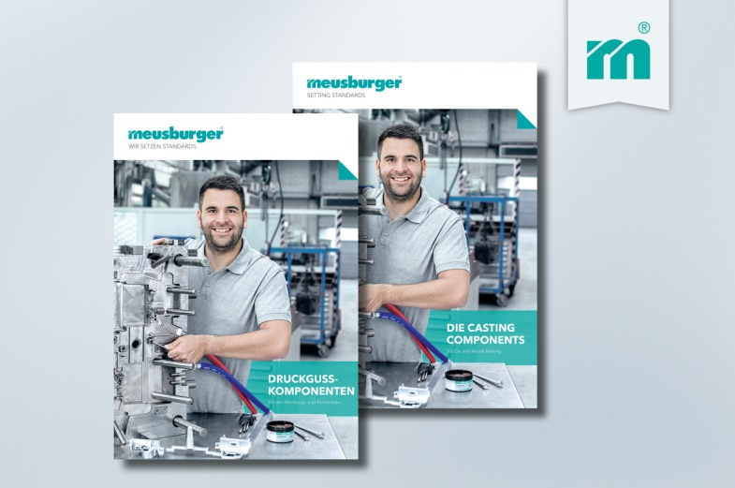

Meusburger Group – Setting Standards

The Meusburger Group is the leading international manufacturer of high-quality standard parts, hot runner and control systems and selected items in workshop equipment. More than 17,500 customers all over the world make use of the numerous advantages of standardisation and benefit from the company's over 50 years of experience in working with steel. The permanent availability of products makes the Meusburger Group the reliable and global partner for die, mould, jigs and fixtures construction.

Further information:
Meusburger Georg GmbH & Co KG
Communication / Public relations
Lia Klimmer
Phone: + 43 5574 6706-1446
Email: presse@meusburger.compresse@meusburger.com
http://www.meusburger.com/en/press/press.html

