Press Release
Wolfurt, on 13/08/2019

A new generation of ejectors for inclined ejection units

For easier demoulding of internal undercuts in plastic parts, ejectors for inclined ejection units can often be used instead of slide units. With the new E 3270 Inclined ejection unit, Meusburger offers a cost-effective and ready-to-use alternative to the existing ejectors for inclined ejection units on the market. The part geometry is created with a block for eroding which allows for maximum design flexibility. The DLC coating of the ejector rod ensures minimal wear, best sliding properties and ultimately a long service life.

Functional principle
The inclined slide unit essentially consists of three parts and the functional principle is very simple: a rectangular block for eroding - available in various sizes - is machined by wire EDM according to the undercut. This is now mounted into a groove by means of an ejector rod fastened in the ejector set. The ejector rod slides along the ejector rod guiding unit which is screwed flush to the back of the intermediate or cavity plate. Thanks to the rectangular design, the guiding unit has an optimal contact surface. At the same time, static indeterminacy and therefore self-stress of the lateral guiding unit can be prevented. If the ejector set is moved forward, the machined block for eroding slides along the groove and releases the undercut in the plastic part. The inclined ejection unit is available in eight different sizes and strokes range from 4 to 8 mm with a maximum angle of 10°.

Optimal combination of materials
The DLC coating of the ejector rod in material grade 1.2767 ensures optimal sliding friction between the ejector rod and the block for eroding and between the ejector rod and the matching guiding unit made of tin bronze. The block for eroding is supplied in material grade 1.2343 ESR with a hardness of 54-2 HRC. Thanks to this hot-work steel in ESR grade, polishing is also possible.

Block for eroding provides maximum design flexibility
Generally, four ejectors can be produced from one E 3272 Block for eroding for inclined ejection unit. Meusburger offers the block in four different sizes. The already introduced contour for the guiding unit as well as the possibility of batch processing during wire EDM ensure the shortest machining times. The angle of the ejector which is optimal for the application can be selected. This means that the stroke can also be adapted exactly to design. This is particularly advantageous if the space for the ejector is limited or there is a difficult geometry on the plastic part. The thickness of the block for eroding is ground and ready-to-use, but can be reground to any thickness from 7 to 20 mm if required.

CAD data including installation spaces is immediately available
As usual at Meusburger, the CAD data for the E 3270 Inclined ejection unit is immediately available for download. In addition, the installation spaces can be generated immediately – which saves a lot of time during the design process. The inclined ejection unit as well as the block for eroding are available from stock.

Meusburger offers a product video with interesting information about the ejectors for inclined ejection units – just click here and take a look.

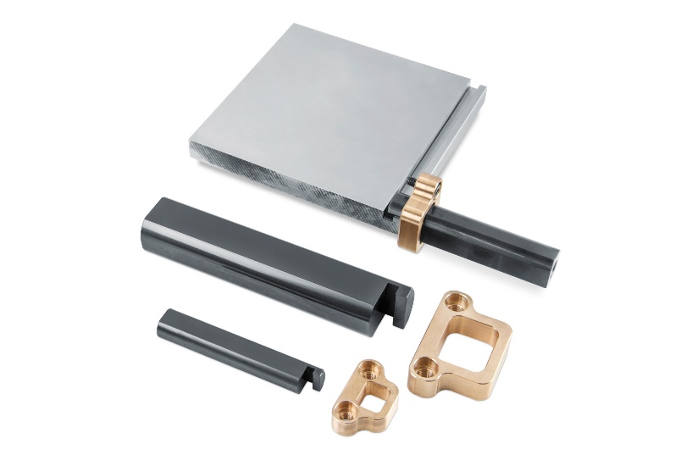

Image source: Meusburger, publication free of charge
Caption: A new generation of ejectors for inclined ejection units

Meusburger – Setting Standards.

As a part of the Meusburger Group, the Meusburger company is the market leader in the field of high-precision standard parts. 21,000 customers all over the world make use of the advantages of standardisation and benefit from the company's over 50 years of experience in working with steel. Offering an extensive range of standard parts, combined with selected products in the field of workshop equipment, Meusburger is the reliable global partner for making moulds, dies, jigs and fixtures.

Press contact

Meusburger Georg GmbH & Co KG
Communication / Public relations
Phone: +43 5574 6706-0
Email: press@meusburger.com
www.meusburger.com

