Press Release
Wolfurt, on 18/06/2019

Cavity pressure measurement for increased process efficiency in injection moulding

According to the motto ‘everything from one source’, in addition to standard parts for temperature and end position control, Meusburger now also offers sensors for cavity pressure measurement. With the matching connecting cable, these are compatible with all systems for analysis currently available on the market. The range includes two types each for direct and indirect measurement as well as suitable mounting accessories and connection cables - as usual available from stock with simple CAD data download from the Meusburger web shop.

The cavity pressure is an important parameter in process monitoring during plastic injection moulding. Pressure sensors are therefore indispensable for comprehensive mould monitoring. The use of high-quality piezoelectric sensors leads to optimal process quality and increases part quality sustainably.

Functional principle and uses of cavity pressure sensors
Cavity pressure sensors make it possible to convert the pressure in the cavity to a measurable charge by means of the piezoelectric effect. The sensors are equipped with high-precision quartz crystals (SiO₂ or α-quartz) which release a charge under the influence of pressure or force. This charge, amplified by a charge amplifier, provides precise information about the pressure applied to the sensor and makes it possible to monitor the exact cavity pressure in the injection moulding process. The ideal installation position in the mould depends on the application. For example, for general monitoring and process optimisation, the sensor is placed as close as possible to the sprue or on a thicker section of the moulded part. Other typical applications are strength monitoring and monitoring or controlling viscosity, compression or shrinkage.

Direct and indirect cavity pressure sensors
Depending on the application, there are two types of pressure sensors: direct and indirect sensors, which serve for direct or indirect pressure measurement.

Meusburger E 6740 Cavity pressure sensor for direct measurement
For direct measurement, the pressure sensor is inserted directly into the cavity so the cavity pressure can be measured directly in the respective area. When pressure is applied, the sensor delivers an electrical charge in the pC unit (Picocoulomb), which is then converted into a change of pressure (bar) through the specified sensor sensitivity (pC/bar).

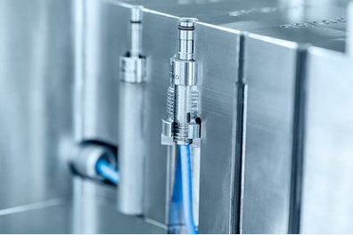
Image source: Meusburger, publication free of charge
File name: IMG_PRO_E6740-Werkzeuginnendrucksensor-direkt-2
Caption: Meusburger E 6740 Cavity pressure sensor for direct measurement

Meusburger E 6750 Cavity pressure sensor for indirect measurement
The indirect measurement of the cavity pressure is carried out via a force sensor which is located outside the cavity and is indirectly actuated by a force. Unlike direct sensors, the cavity pressure is transmitted to the sensor as a force via an ejector pin. In response to this force, the sensor emits an electrical charge, which is then converted into a change of force (N) through the specified sensor sensitivity (pC/N). This change of force combined with the surface of the ejector is used to calculate the pressure change.

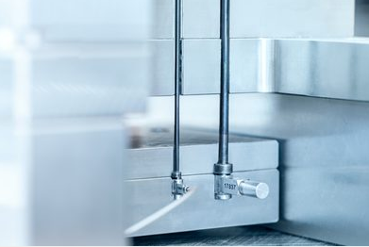
Image source: Meusburger, publication free of charge
File name: IMG_PRO_E6750-Werkzeuginnendrucksensor-indirekt-2
Caption: Meusburger E 6750 Cavity pressure sensor for direct measurement

Meusburger – Setting Standards.

As a part of the Meusburger Group, the Meusburger company is the market leader in the field of high-precision standard parts. 21,000 customers all over the world make use of the advantages of standardisation and benefit from the company's over 50 years of experience in working with steel. Offering an extensive range of standard parts, combined with selected products in the field of workshop equipment, Meusburger is the reliable global partner for making moulds, dies, jigs and fixtures.

Press contact

Meusburger Georg GmbH & Co KG
Communication / Public relations
Phone: +43 5574 6706-0
Email: presse@meusburger.com
www.meusburger.com

