Meusburger Georg GmbH & Co KG
Kesselstr. 42, 6960 Wolfurt, Austria

Double output thanks to the new Meusburger gear unit for stack moulds

For the synchronous control of stack moulds Meusburger offers the stable and precise E 8630 Gear unit for stack moulds in two compact sizes. The two types in module 3 or module 4 stand for the highest precision and quality. The closed housing provides highest stability and safety.

More efficiency and precision in the production
The production is more efficient with stack moulds. Compared to classic moulds, twice as many parts can be produced in each injection cycle in the two stacks. The closing force of the mould remains the same. For this purpose, the standard parts manufacturer Meusburger offers the E 8630 Gear unit for stack moulds. The new product from the demoulding category stands for highest precision since the assembly is equipped with ground and induction hardened gear racks and gear wheels. These are available with a length of 800 to 1,200 mm and in module 3 or module 4. Thanks to the smaller tooth size a more accurate synchronisation is achieved.

Highest stability and durability in compact form
The closed housing guarantees highest stability and more safety for the user. An additional advantage is the DLC coating of the force-absorbing gliding plate by which the wear is reduced compared to the conventional varieties and the durability is extended. The new product was designed as compact as possible so it can also be used in injection moulding machines with a small tie-bar spacing. The installation and exact positioning is simple and can be done either via milled pockets or dowel holes.

You are just a few clicks away from the appropriate version
For a quick and easy selection of the appropriate drive, the tables with important specifications such as maximum load and operating temperature and further information are available in the online shop. With just a few clicks, the corresponding product can be compiled and the 3D data is generated and downloaded.

As usual with Meusburger the gear unit for stack moulds is available from stock. As of June Meusburger will provide further information on the advantages of this product in a so-called ‘technical tip’ on its YouTube channel: www.youtube.com/meusburger.

Picture credits: Photo (Meusburger)
Caption: Double output thanks to the new Meusburger gear unit for stack moulds

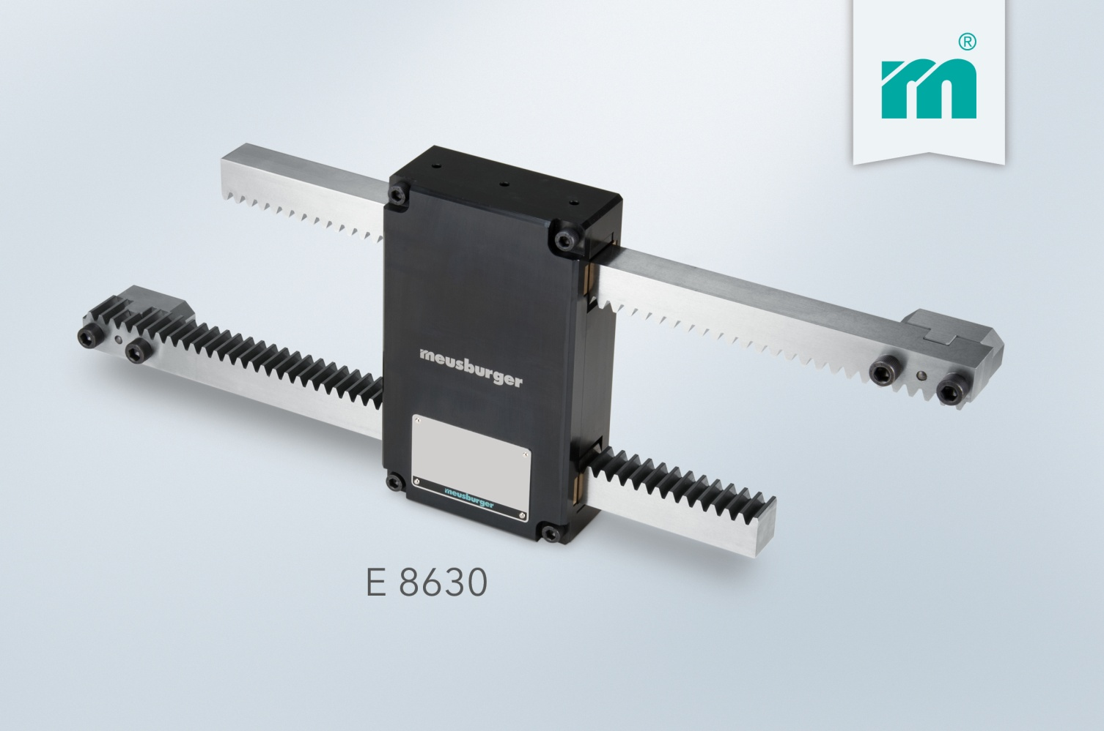

Meusburger – Setting Standards
Meusburger is the leading manufacturer of high-precision standard parts. More than 17,000 customers all over the world make use of the numerous advantages of standardisation and benefit from the company's over 50 years of experience in working with steel. Offering an extensive range of standard parts, combined with high-grade products in the field of workshop equipment, Meusburger is the reliable global partner for making dies, moulds, jigs and fixtures.

Further information:
Meusburger Georg GmbH & Co KG
Communication / Public relations
Lia Klimmer
Phone: + 43 5574 6706-1446
Email: presse@meusburger.compresse@meusburger.com
http://www.meusburger.com/en/press/press.html

